**NYSED WIRESHARK PROJECT**

**Team A (Srivarsha & John)**

**Below is the summary notice of WokeMountain.DC Pcap:**

Source of incident: 10.1.21.101

Date the breach was discovered: 21-01-2021

Date of the disclosure: 08-14-2025

**WIRESHARK EVIDENCE ANALYSIS**

**What Happened (Chronological PCAP summary)**

**Stage 1 – Initial Malicious Contact & Config Retrieval**

The intrusion began when the infected workstation 10.1.21.101 initiated an HTTP GET request to the raw IP 209.141.51[.]196 for /Lk9tdZ. The server replied with an **HTTP 302 Found** status, redirecting the client to /files/1.bin. This .bin file, path was inspected in virus total, matched the structure and encryption patterns of a **Zeus/Zbot configuration file.**

**Stage 2 – Benign 404 Verification**

Another .bin request to 96.17.66[.]27 returned 404 Not Found. The returned HTML body resembled a legitimate Microsoft IIS error page, including references to common Microsoft CDN domains (ajax.aspnetcdn.com, assets.onestore.ms, akamaiedge.net). This traffic was classified as harmless, likely background activity unrelated to the intrusion.

**Stage 3 – Payload Delivery**

Subsequent HTTP GETs from 209.141.51[.]196 were delivered using **MSXMLHTTP**/VBScript request patterns — a method typical of Windows script-based downloaders. The payloads often arrived without a file extension or disguised as .jpg. Wireshark TCP stream reassembly revealed MZ headers (0x4D 0x5A) — the Windows executable signature — in all suspected payload responses. Sizes were consistently under 1 MB, indicating initial loader binaries rather than full-size payloads.

**Stage 4 – Secondary Payload from greatewallfirewall[.]xyz**

The infected host contacted greatewallfirewall[.]xyz (185.186.244[.]130) over HTTP, requesting paths like /postfix/M_2FMDBMTxi/.... These long-encoded segments appear auto generated to evade signature detection. Response bodies contained PE files disguised under various names. Notable retrieved files include:

* favicon.ico — SHA256: e78286d0f5dfa2c85615d11845d1b29b0bfec227bc077e74cb1ff98ce8df4c5a
* Tj4t.yml — SHA256: cde859855eefdc66a7d3c24bd0577b8dbfcc12ed5e404f0fdf7cc9fef5393f85

**Stage 5 – Encrypted Command & Control**

TLS sessions were initiated to 72.21.81[.]200 with JA3 fingerprints linked to the **Gozi** banking trojan family. The Server Name Indication (SNI) fields were spoofed to appear as legitimate Microsoft services (iecvlist.microsoft.com), a tactic known as TLS SNI fronting. Other SSL sessions connected to:

* 193.239.84[.]250 — Zeus Panda infrastructure
* 184.252.95[.]102 — Ursnif malware

Several sessions had SNI values set to localhost.localdomain, This tricks monitoring systems into thinking the traffic is going to a trusted site, making it harder to detect command-and-control communications.

**Stage 6 – RPC Abuse and Credential Theft (DCSync)**

The most significant activity observed was the use of DRSUAPI replication calls from the compromised workstation (infected machine) to the domain controller. This sequence included:

* **DsBind** to establish a replication session
* **Bind Ack** confirming the connection
* **DsCrackNames** to resolve account names to distinguished names
* **DsUnbind** to close the session

Additional traffic showed DCERPC bindings to LDAP and Netlogon services, along with **NetlogonGetDomainInfo** requests. Endpoint Mapper (EPM) lookups confirmed that the attacker was enumerating available RPC services.

Analysis indicates that the attacker leveraged the **ZeroLogon (CVE-2020-1472)** vulnerability to authenticate to the domain controller from the infected machine without valid credentials, enabling them to perform DRSUAPI replication. This behavior is consistent with **MITRE ATT&CK T1003.006 (DC Sync)**, where an adversary abuses domain controller replication to extract account credentials.

**Stage 7 – Public IP Lookup**

DNS queries to myip.opendns[.]com at resolver 208.67.222[.]222 requested both IPv4 and IPv6 records. This is a known malware tactic to retrieve the public IP of the compromised network for reporting back to C2. One malformed query to myip.opendns.com.wokemountain.com indicates either misconfigured malware or deliberate attempt to blend with local DNS namespace.

**Stage 8 – Attempted Archive Retrieval**

A HTTP GET to 162.0.224.165 for grab32.rar returned 404 Not Found. .rar files in malware operations are often used for staging stolen data or delivering multi-component payload bundles.

**How Was Disclosure Discovered:**

The breach was identified through a mix of IDS alerts and manual PCAP analysis.

* **IDS Alerts :** Flagged suspicious activity such as Zeus/Zbot config file retrieval, VBScript-based downloads, TLS fingerprints matching Gozi, and SSL certificates linked Ursnif.
* **Wireshark Review:** Confirmed DCSync packet sequences, found embedded PE files in TCP streams, mapped hosts to users via SMB/Netlogon, and spotted unusual DNS queries to command-and-control IPs.

**Summary of Events:**

This incident involved a **multi-family malware operation** that combined the capabilities of Zeus/Zbot, Gozi, and Ursnif. The sequence shows:

1. Initial infection from a raw IP-based HTTP download.
2. Multiple staged payload deliveries via obfuscated URIs and script-based downloaders.
3. Encrypted communications to a blend of known banking malware C2 nodes.
4. Active Directory replication abuse to harvest credentials at scale.
5. Reconnaissance of external network footprint.
6. Preparation for possible multi-file staging or exfiltration.

**Methodology Summary**

* Used a separate Kali Linux virtual machine, fully isolated from the network.
* Captured system snapshots and PCAP files at the start to preserve evidence.
* Did not download or execute malicious files; generated file hashes for analysis.
* Investigated domains, IPs, and hashes using trusted threat intelligence platforms.
* Cross-referenced Suricata IDS alerts with PCAP data in Wireshark to confirm activity.

**Obfuscation Techniques Observed:**

The attacker used several delivery and evasion tactics, each aimed at slipping past security controls:

* Instead of using hostnames, the malware reached out directly to 209.141.51[.]196 to pull /Lk9tdZ and /files/1.bin.This avoided DNS lookups entirely, sidestepping domain-based filters and DNS log monitoring.
* Some payloads were given .jpg extensions but were actually Windows PE binaries.  
   HTTP headers claimed image/jpeg, yet binary inspection showed MZ headers.
* Requests like /postfix/M_2FMDBMTxi/... contained long, randomized strings.  
   This breaks simple signature-based IDS rules, pushing analysts to rely on behavior instead of static path matching.
* In TLS handshakes, the SNI(Server Name Indication) field was set to iecvlist.microsoft.com — a legitimate Microsoft domain — while actually pointing to Gozi C2 servers. This made malicious traffic blend in with common corporate HTTPS flows.
* Payloads were under 1 MB, likely acting as first-stage loaders that pulled additional modules later. This reduces the detection surface during transfer and allows partial compromise if later stages are blocked.

**Member(s) Impacted:**

* **Domain Targeted:** wokemountain.com
* **Infected Host IP:** 10.1.21.101
* **Infected Host MAC Address:** 00:60:67:d3:47:8b — Vendor: Acer Incorporated
* **Domain Controller (DC):** 10.1.21.2 (hostname: WokeMountain-DC).
* **Infected Hostname:** DESKTOP-NB72TZA.wokemountian.com (NetBIOS name: DESKTOP-NB72TZA$).
* **Infected Machine User:** Orlando Mcoy

**Root Cause:**

The root cause of this incident is traced to a **malicious configuration file retrieval** from a hardcoded raw IP address:

* The .bin file fetched from 209.141.51.196 served as the initial configuration for Zeus/Zbot malware.
* This configuration instructed the malware where to download payloads, how to connect to C2 servers, and which web domains to target for credential theft.
* The infection was likely triggered by:
  + Malicious email attachment
  + Compromised website download
  + Or a drive-by download delivering the loader silently
* Once active, the malware initiated further payload retrieval, encrypted C2 communications, and domain replication abuse — leading to full domain compromise potential.

**Corrective Action:**

* Disconnect the affected workstation from the network, block malicious IPs/domains, and stop related TLS fingerprints.
* Reset all AD passwords (starting with privileged accounts), invalidate Kerberos tickets, and enforce strong password policies.
* Limit workstation-to-DC access, deploy EDR logging, and enable auditing for unauthorized replication attempts.

**Indicators of Compromise:**

|  |
| --- |
| IP Address |
| 209.141.51[.]196/Lk9tdZ |
| 209.141.51[.]196/files/1.bin |
| 96.17.66[.]27 |
| 185.186.244[.]130 |
| 72.21.81[.]200 |
| 193.239.84[.]250 |
| 184.252.95[.]102 |
| 208.67.222[.]222 |
| 162.0.224.165/grab32.rar |
| 104.95.253.170/Tj4t.yml |
| 185.186.244.130/g.yml |
| 185.186.244.130/A34L.yml |
| 23.15.4.25/ DSTROOTCAX3CRL.crl |
| 193.239.84.250/booloolo3.com |
| 84.252.95.102/booloolo4.com |

|  |
| --- |
| Domains |
| greatewallfirewall[.]xyz |
| iecvlist.microsoft.com |
| myip.opendns[.]com |
| booloolo2.com |

|  |  |
| --- | --- |
| **Hashes** | SHA256 |
| favicon.ico | e78286d0f5dfa2c85615d11845d1b29b0bfec227bc077e74cb1ff98ce8df4c5a |
| Tj4t.yml | cde859855eefdc66a7d3c24bd0577b8dbfcc12ed5e404f0fdf7cc9fef5393f85 |

**Findings:**

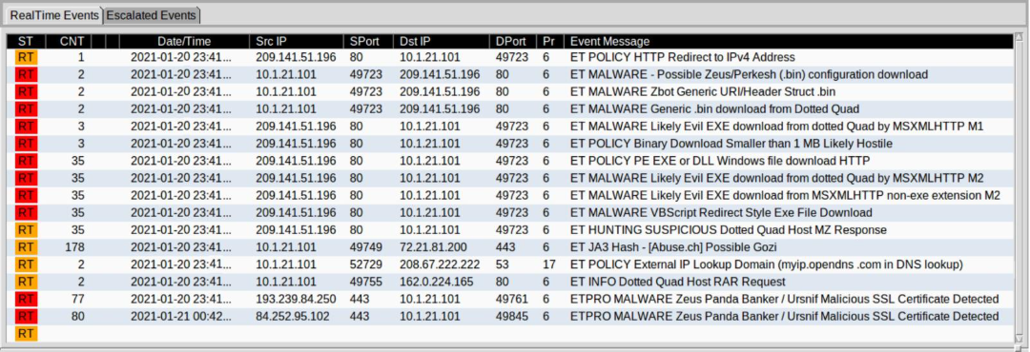

### **Event 1: ET POLICY HTTP Redirect to IPv4 Address**

* **Source IP**: 209.141.51.196 (External server)
* **Destination IP**: 10.1.21.101 (Internal host)

ip.addr == 209.141.51.196 && http

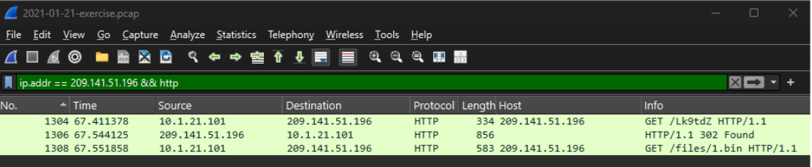

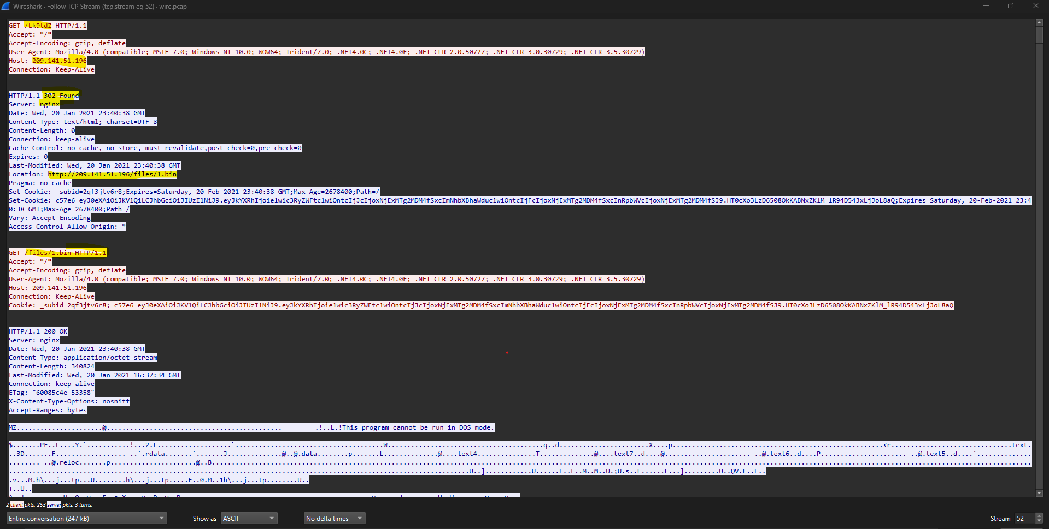

<https://www.virustotal.com/gui/ip-address/209.141.51.196>

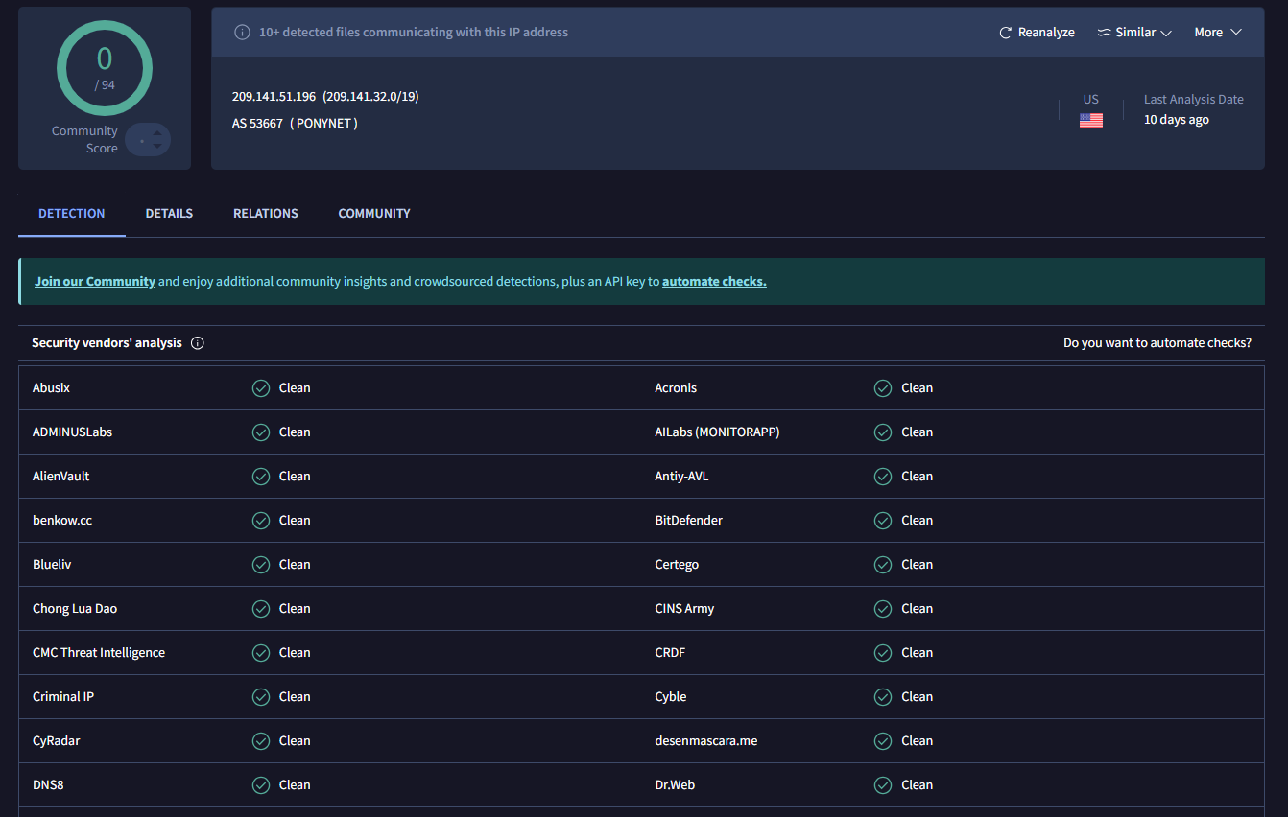

<https://www.virustotal.com/gui/url/1cf2807bd9c4bcb887db918459155b363ffb0c3c8f10cd9a1ea2826bcd5658d1>

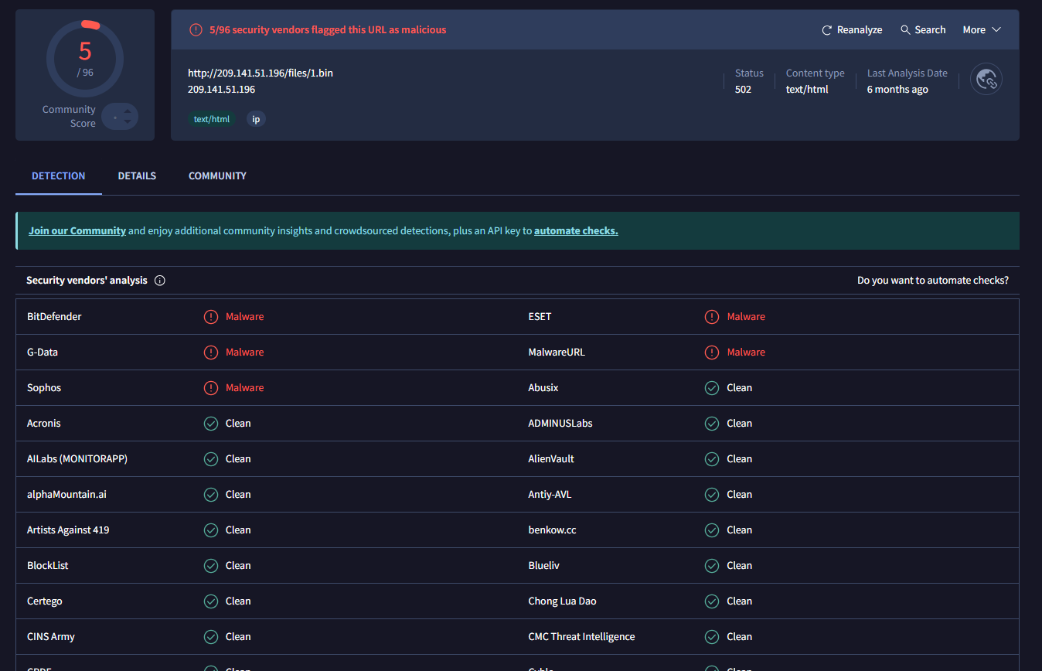

### **<https://www.virustotal.com/gui/url/f3fea90313e37f1a32b7ac571f383331ccae31036983961da031916d8838c273/detection>**

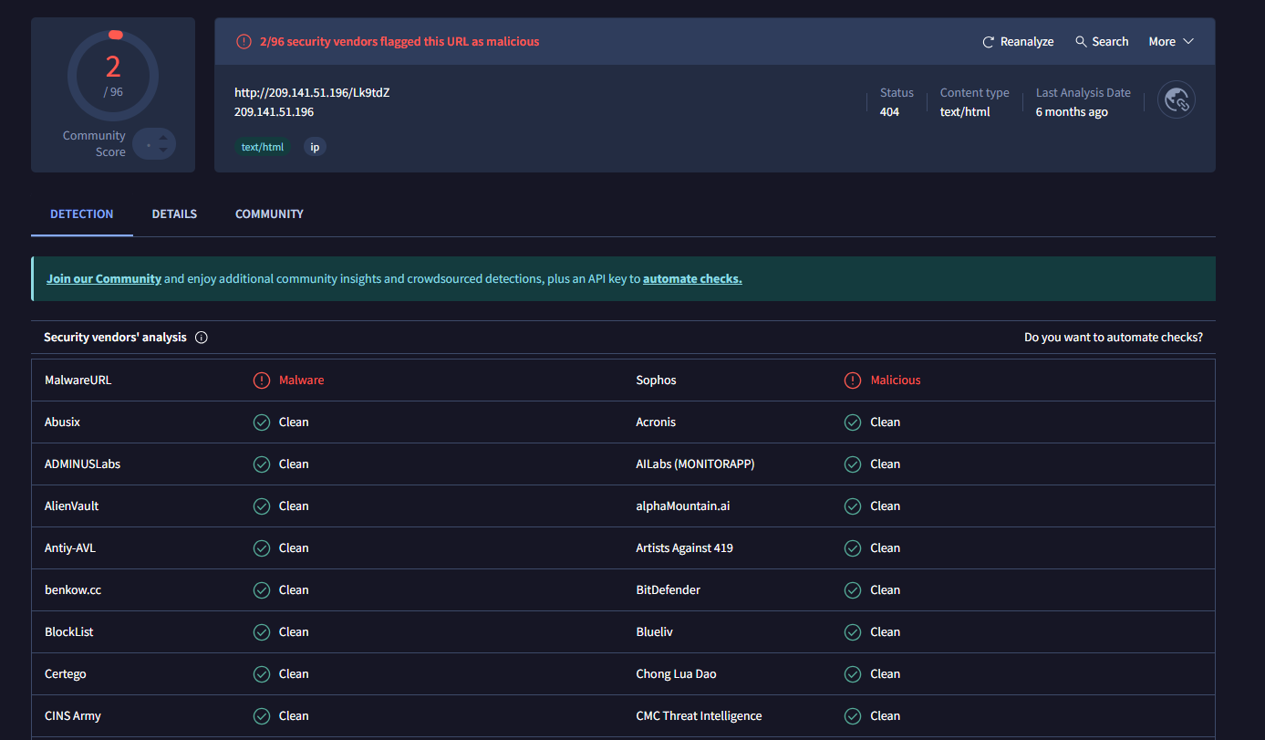

Internal host 10.1.21.101 made an HTTP GET request to 209.141.51.196 for the path /Lk9tdz. The server at 209.141.51.196 responded with an HTTP 1.1 302 Found, redirecting to /files/1.bin. The client then made another GET request to /files/1.bin, and the server responded with HTTP 200 OK, delivering a binary file. All HTTP communication was with 209.141.51.196. This pattern—an initial request to a short path, a redirect, and the download of a binary—is typical of malware delivery.

### **Event 2: ET MALWARE - Possible Zeus (.bin) configuration download**

* **Source IP**: 10.1.21.101
* **Destination IP**: 209.141.51.196

ip.addr == 209.141.51.196 && http.request.uri contains ".bin"

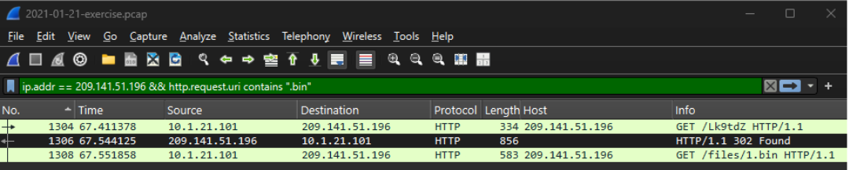

* The internal host followed the redirect and issued a GET /files/1.bin request.
* .bin files are commonly used to deliver configuration for malware like Zeus.
* The source IP is the same as in Event 1, confirming a continued threat interaction.
* This marks the **start of command & control (C2) or malware staging phase**.

### **Event 3: ET MALWARE Zbot Generic URI/Header Struct .bin**

* **Source IP**: 10.1.21.101
* **Destination IP**: 209.141.51.196

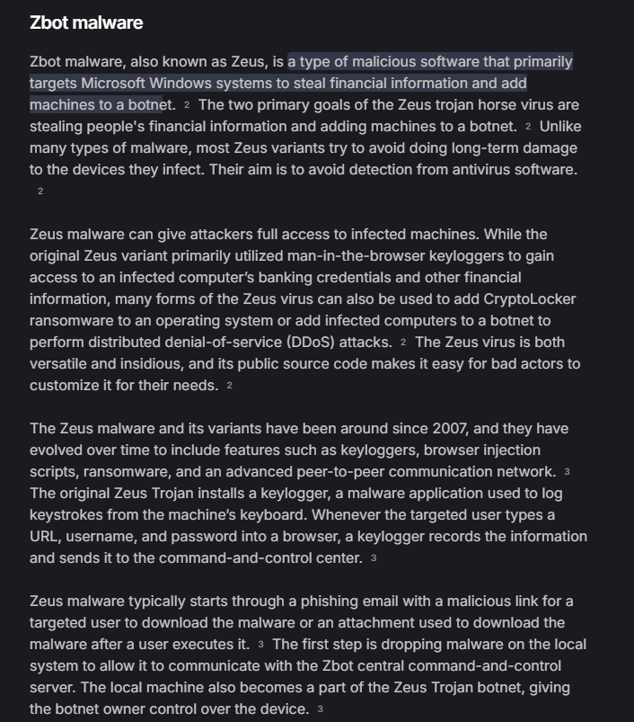

http contains ".bin"

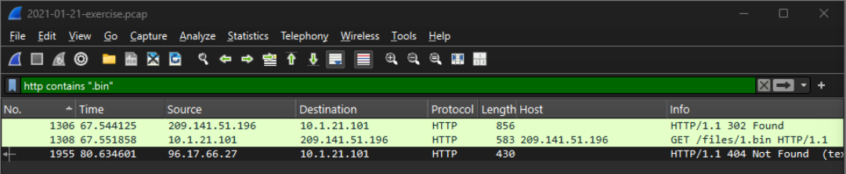

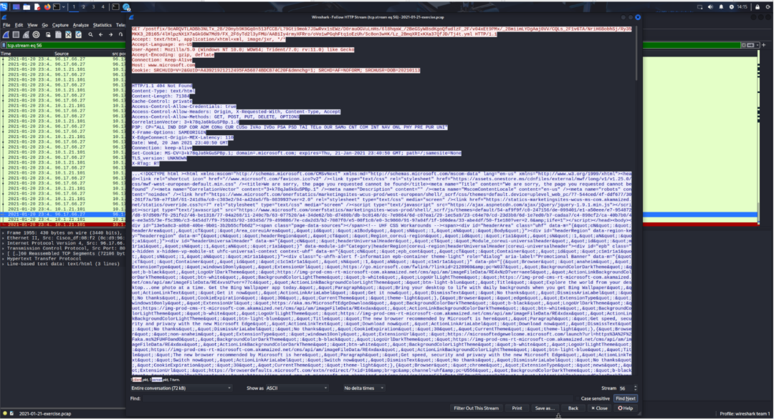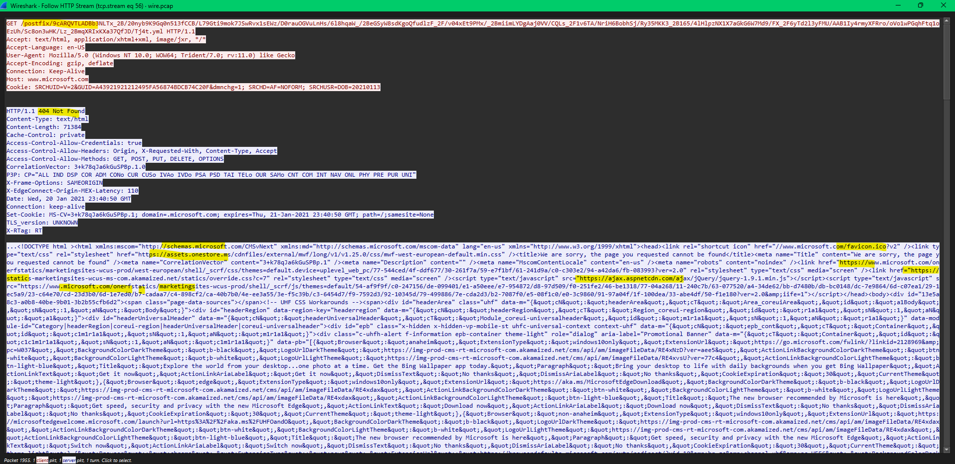

96.17.66.27 sent an HTTP response to 10.1.21.101 with status "404 Not Found" and content type "text/html." This means the client (10.1.21.101) requested a resource from 96.17.66.27 that does not exist on the server. The server responded with an HTML error page, not a binary or executable file. The content of the response is a standard Microsoft-style error page with references to trusted Microsoft domains and CDNs.

The other domains listed in the HTML response—such as:

* microsoft.com
* assets.onestore.ms
* ajax.aspnetcdn.com
* akamai.net
* ms.com
* and other static resource/CDN links

—are **legitimate domains** owned and operated by Microsoft or their official content delivery partners (like Akamai).

These domains are commonly used for serving web content, stylesheets, scripts, and images for Microsoft websites and products. They are not indicators of malware by themselves and are not typically abused in malware campaigns. Attackers *could* potentially try to fake requests to look legitimate, but the domains you see here are standard and expected in Microsoft-generated error pages or web content.

<https://www.virustotal.com/gui/url/ddccba0dd1e31068088f4e3d057d4d1487cce5b2698b2b0220b9574cacc182c8>

<https://www.virustotal.com/gui/url/4b8fb23fa0c05de12c27fac0acc7584734cbc4d76369fed6098ecb28d632507b>

<https://www.virustotal.com/gui/url/bc2f6dc7c808cac26162742bc825e8a60b80be155f4e3ca58b1b111d2422d5e5>

<https://www.virustotal.com/gui/url/12d0bdd9132be5b198af4640a18a48f513e2ee1258c04c558b66a2213c90ffa7>

<https://www.virustotal.com/gui/url/fd53fa3fb99a3303355fde8cc09f8796a8eeb7fc961536a87fe5d46f780c5fc0?nocache=1>

<https://www.virustotal.com/gui/url/812dcbcc600dfc0c98600e9e3346da698569b8a5a8fcd51d07793e707943a6fe>

### **Event 4: ET MALWARE Generic .bin download from Dotted Quad**

* **Source IP**: 10.1.21.101
* **Destination IP**: 209.141.51.196

http.request.uri contains ".bin"

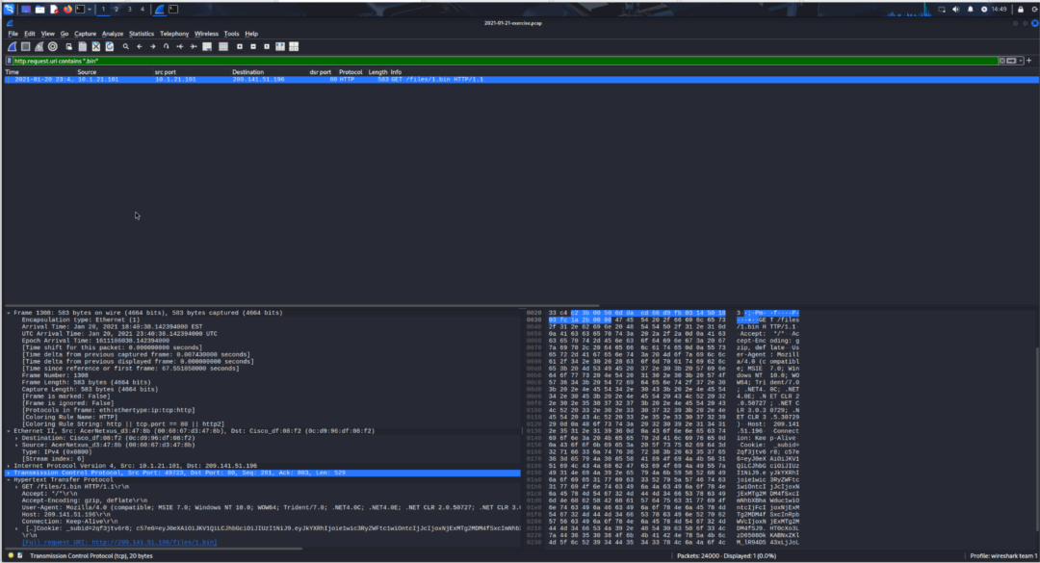

### **Event 5: ET MALWARE Likely Evil EXE download from dotted Quad by MSXMLHTTP M1**

* **Source**: 209.141.51.196
* **Destination**: 10.1.21.101

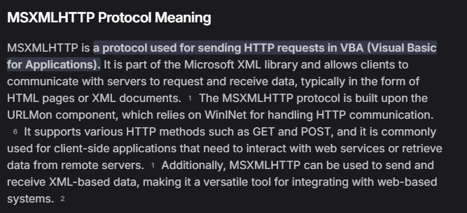

http contains ".exe" or frame contains "MZ"

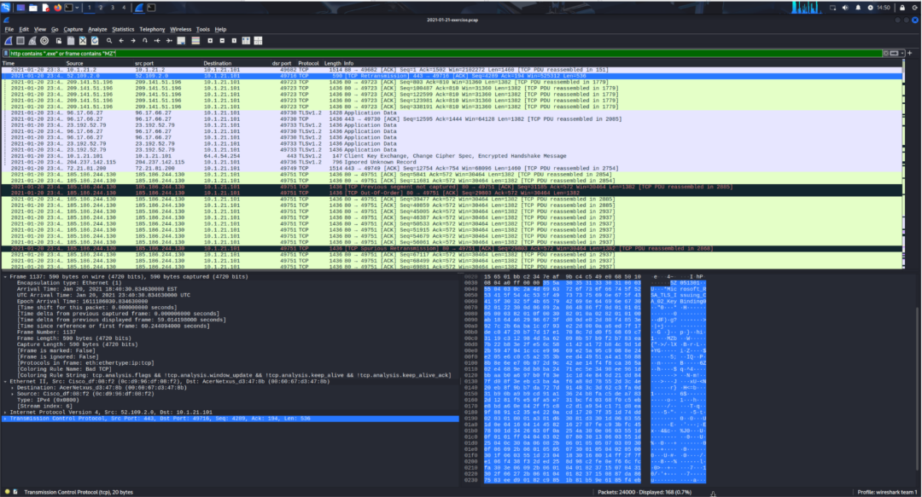

<https://www.virustotal.com/gui/ip-address/185.186.244.130>

* The majority are TCP protocol packets exchanged between internal and external systems. 209.141.51.196 sends multiple TCP segments to 10.1.21.101. These segments collectively transfer data that contains the "MZ" signature, indicating the presence of a Windows executable file. This is consistent with a binary or program being downloaded.
* All observed packets are TCP protocol. This indicates the content was not limited to standard web browsing or application protocols, but rather includes raw data segments, possibly as part of a file transfer. The presence of "MZ" in multiple TCP segments between 209.141.51.196 and 10.1.21.101 shows that a Windows executable was being transferred over the network.
* 209.141.51.196 has been previously identified as a source serving malicious binaries.
* The data exchange with 10.1.21.101 matches known patterns of malicious file delivery (executable download).

### **Event 7: ET POLICY PE EXE or DLL Windows download HTTP**

* **Source**: 209.141.51.196
* **Destination**: 10.1.21.101

http contains "MZ"

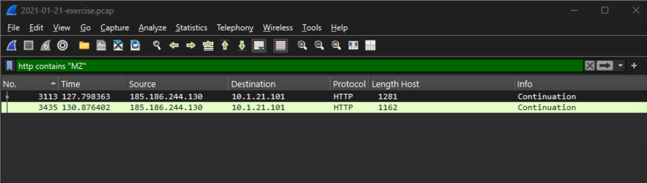

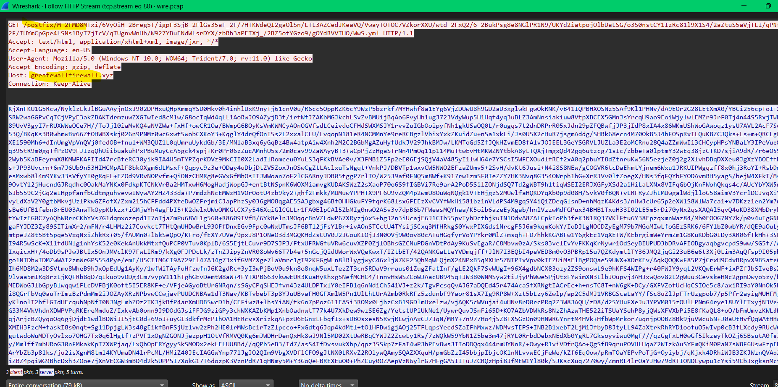

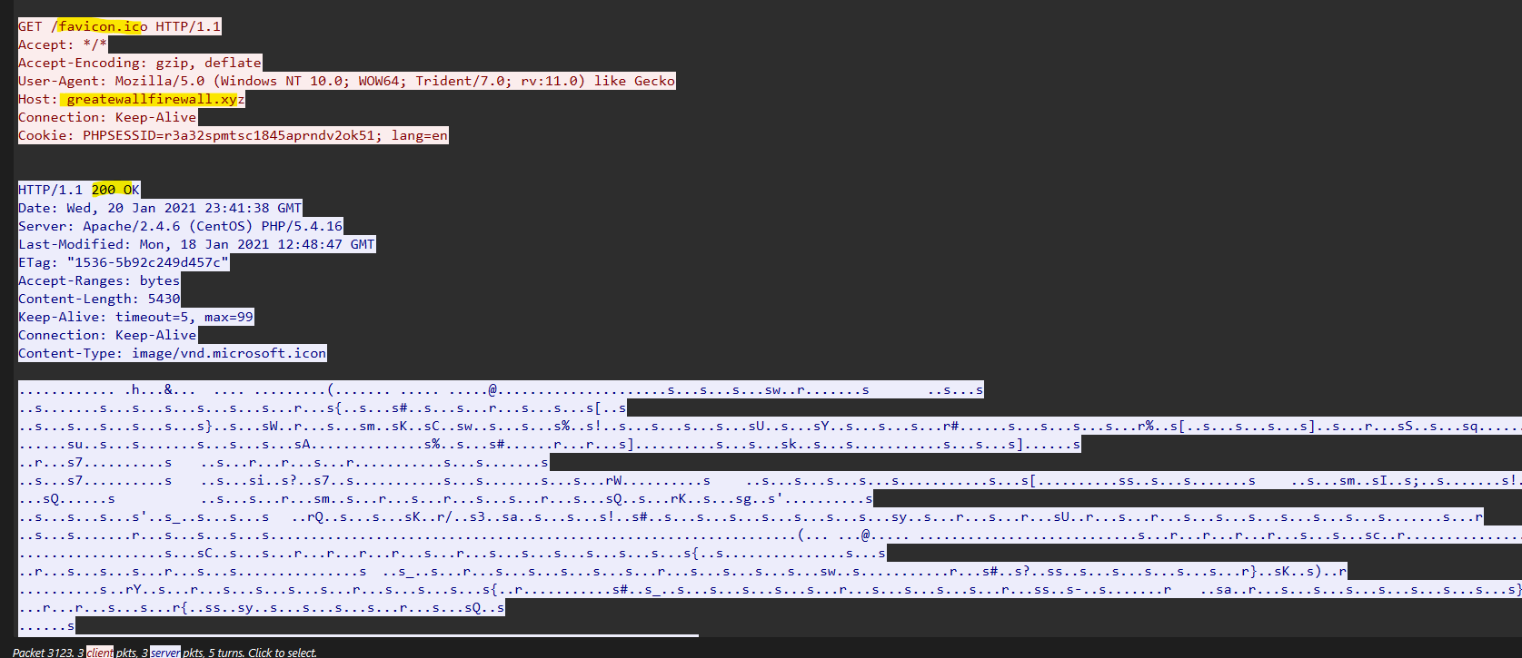

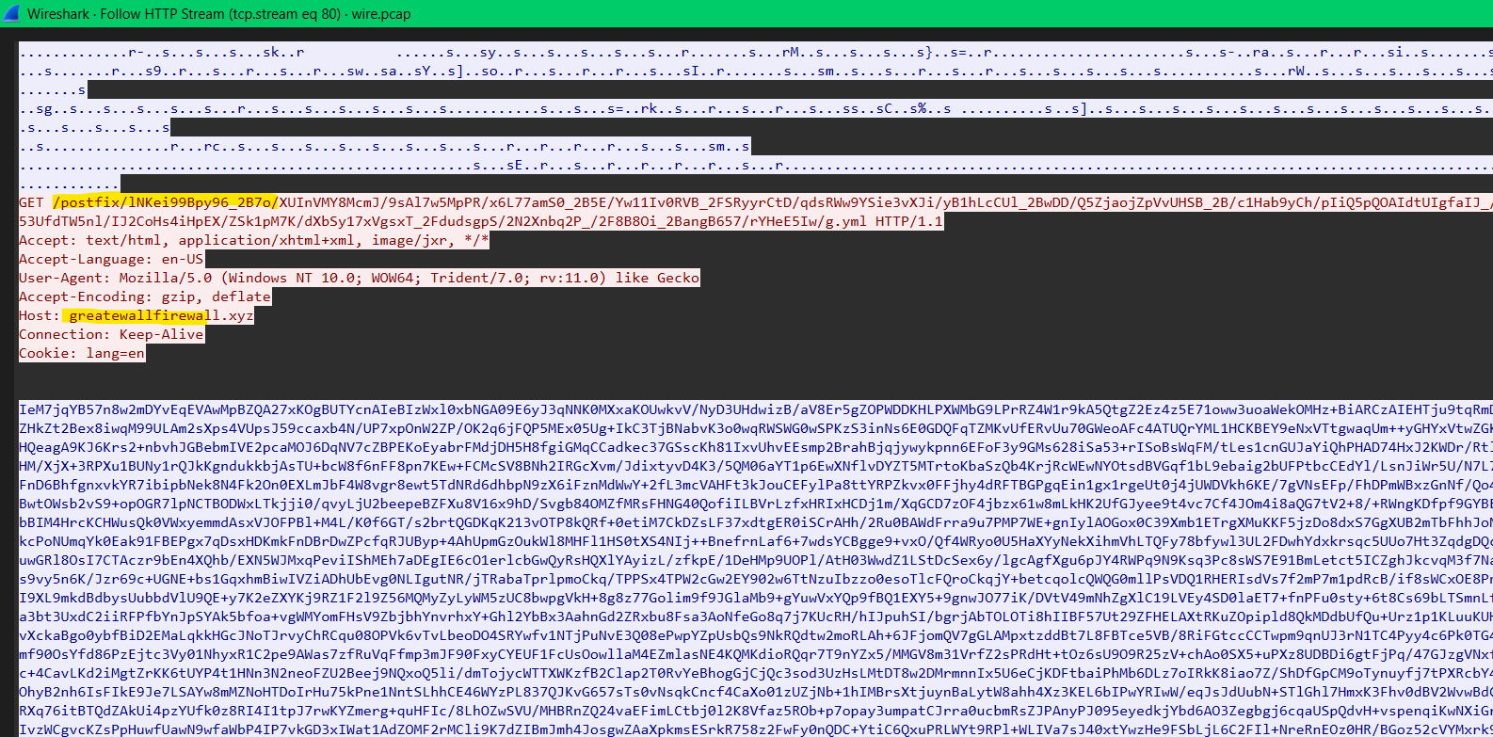

<https://www.virustotal.com/gui/domain/greatewallfirewall.xyz>

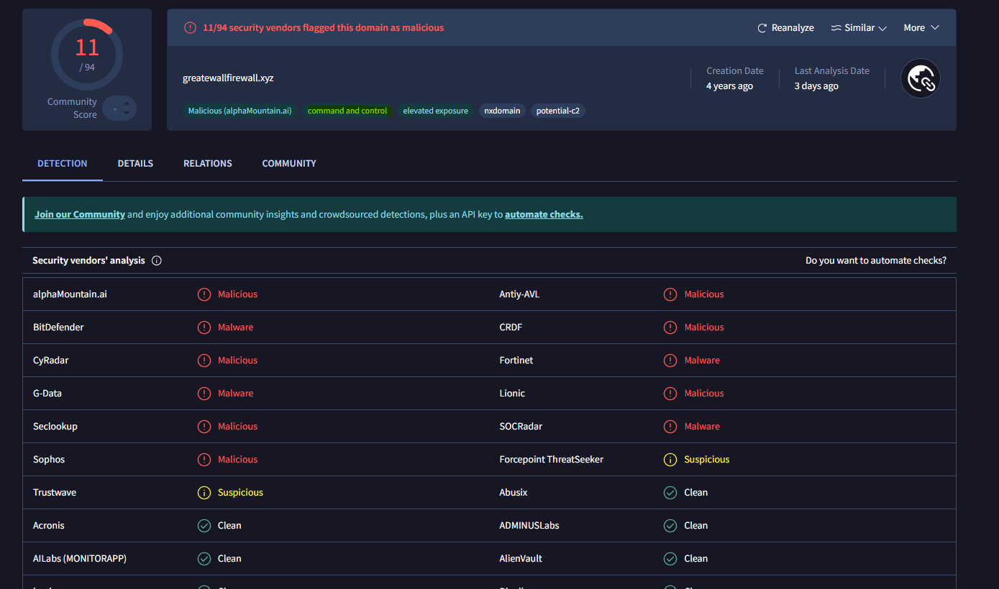

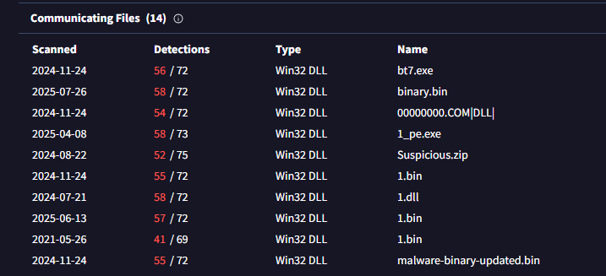

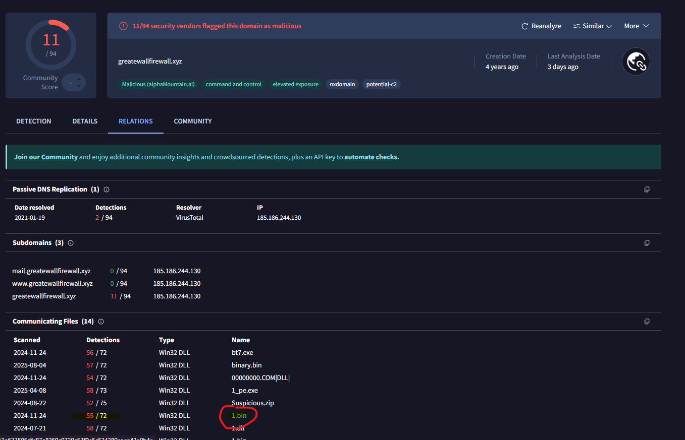

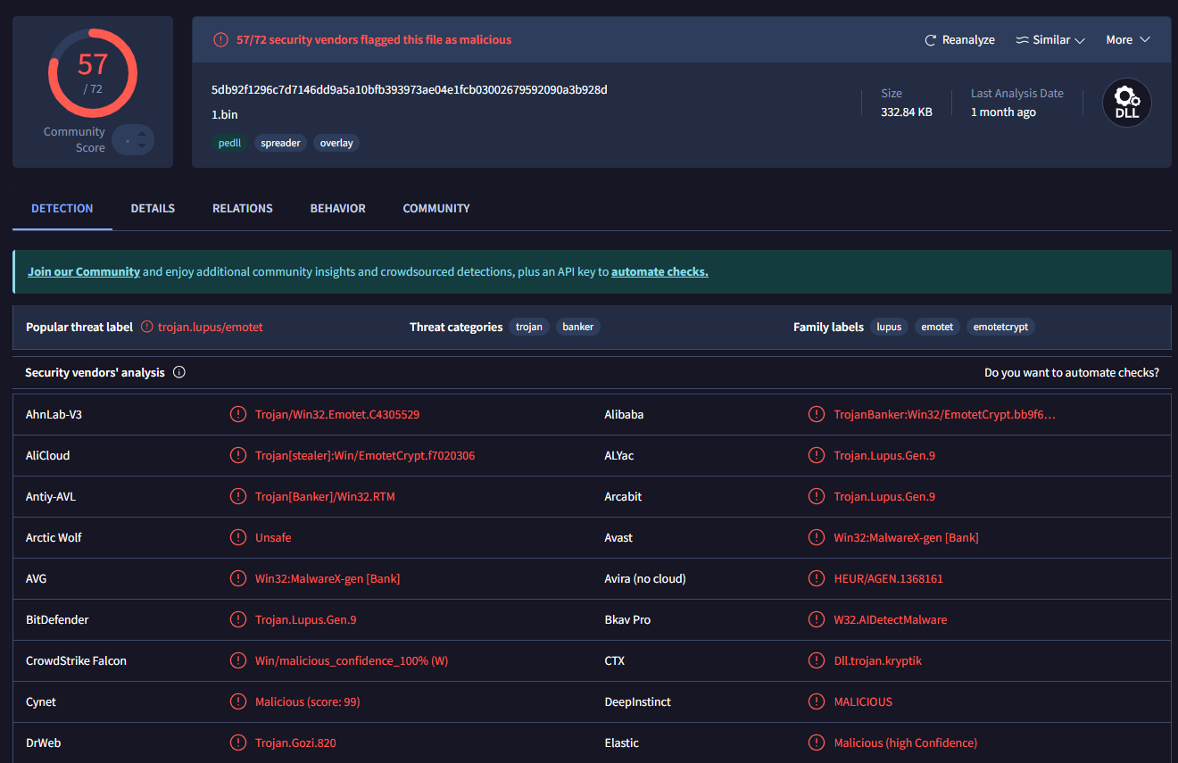

<https://www.virustotal.com/gui/file/4d4a1fe36be94a711e633505dfc87e8359c0739c53f9e5c524280eaea43e0b4e>

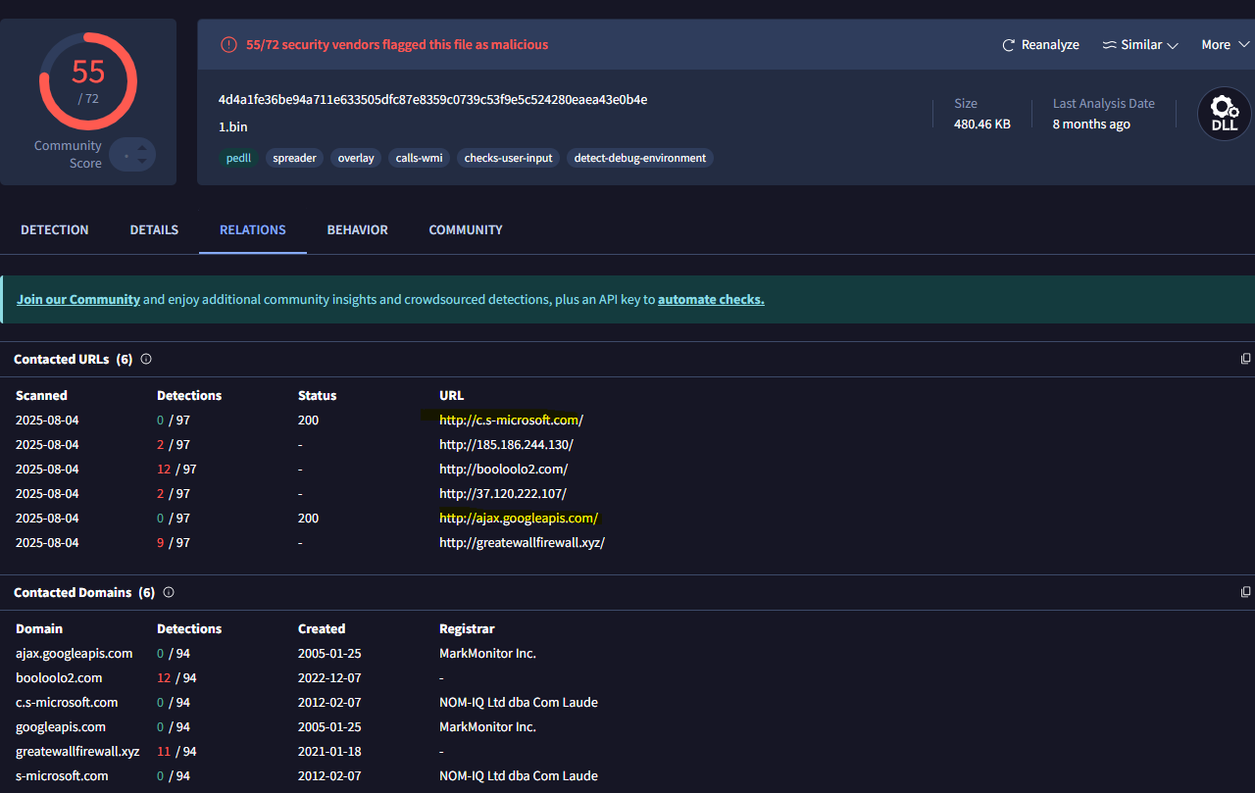

<https://www.virustotal.com/gui/ip-address/185.186.244.130>

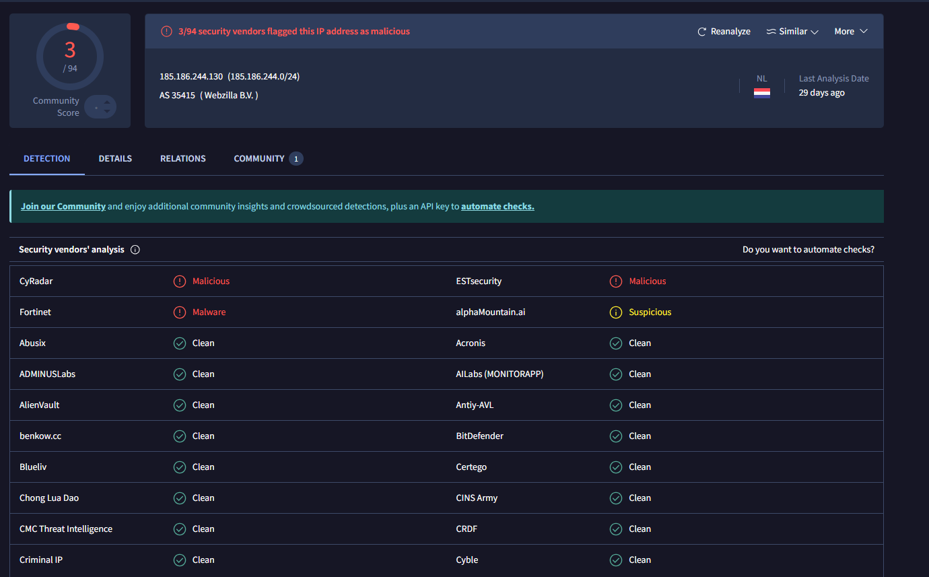

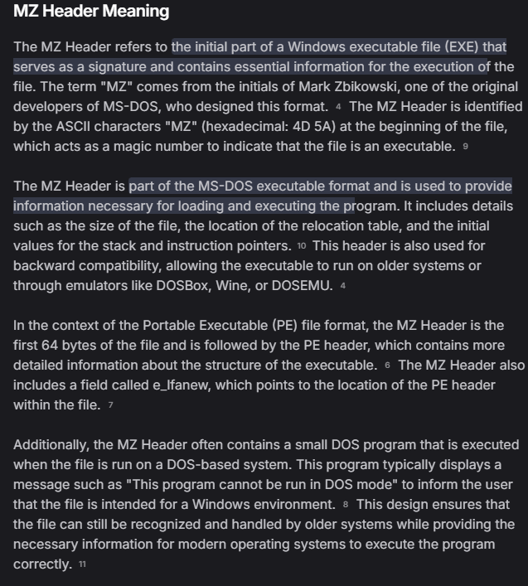

* HTTP communication between 185.186.244.17 and 10.1.21.101, with the filter http contains The HTTP requests are made to the domain greatewallfirewall.[]xyz. The client sends two GET requests with long, suspicious-looking encoded paths (like /postfix/M_2FMDBMTxi/...) and custom cookies. The server replies with large amounts of encoded or binary-looking data. This data likely contains the "MZ" header, which is why the filter matched these packets. The "MZ" header is found at the beginning of Windows executables, so the payload being sent is likely a Windows binary or malicious file disguised within HTTP.
* Additionally, there is a request for /favicon.ico to the same domain. The server responds with a 200 OK and sends back icon file data. While this could be benign, the domain greatewallfirewall[.]xyz is suspicious, The use of encoded paths and binary payloads over HTTP to an unusual domain further supports the likelihood of malicious activity.
* In summary, 185.186.244.17 is delivering binary or executable data to 10.1.21.101 via HTTP through the suspicious domain greatewallfirewall[.]xyz, and the communication involves payloads that match the signature of Windows executable files.

### **Event 11: ET HUNTING SUSPICIOUS Dotted Quad Host MZ Response**

* **Source**: 209.141.51.196
* **Destination**: 10.1.21.101

frame contains "MZ" or tcp contains "MZ"

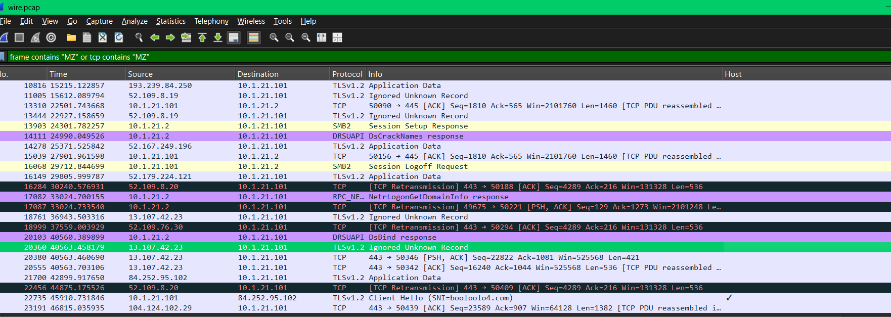

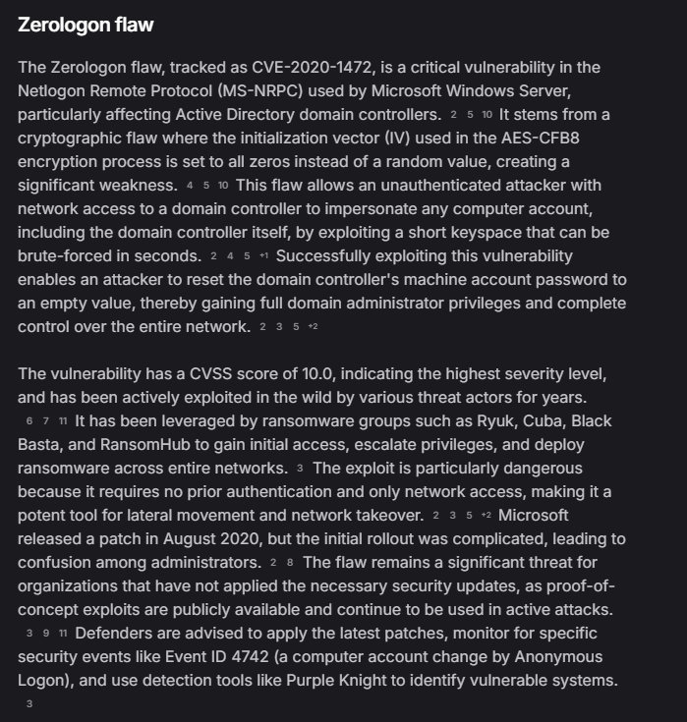

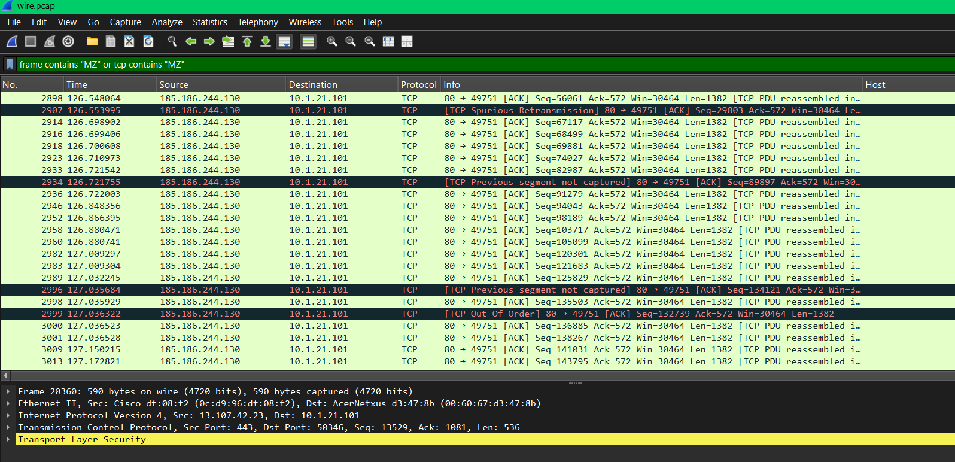

<https://www.virustotal.com/gui/ip-address/96.17.66.27>

<https://www.virustotal.com/gui/ip-address/23.192.52.79>

<https://www.virustotal.com/gui/ip-address/204.237.142.115>

<https://www.virustotal.com/gui/ip-address/72.21.81.200>

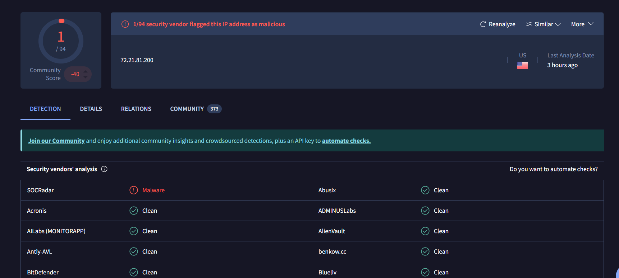

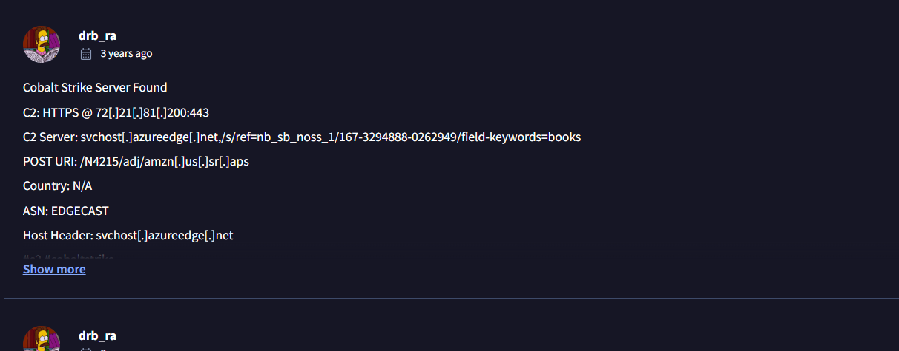

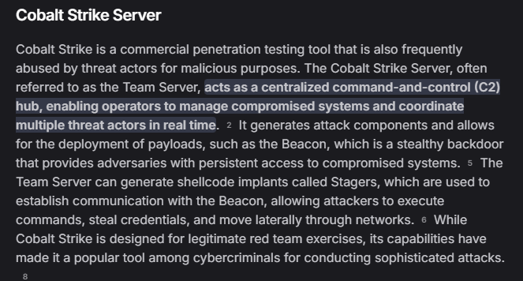

<https://www.virustotal.com/gui/ip-address/52.109.8.19>

<https://www.virustotal.com/gui/ip-address/52.179.224.121>

<https://www.virustotal.com/gui/ip-address/52.109.88.36>

<https://www.virustotal.com/gui/ip-address/193.239.84.250>

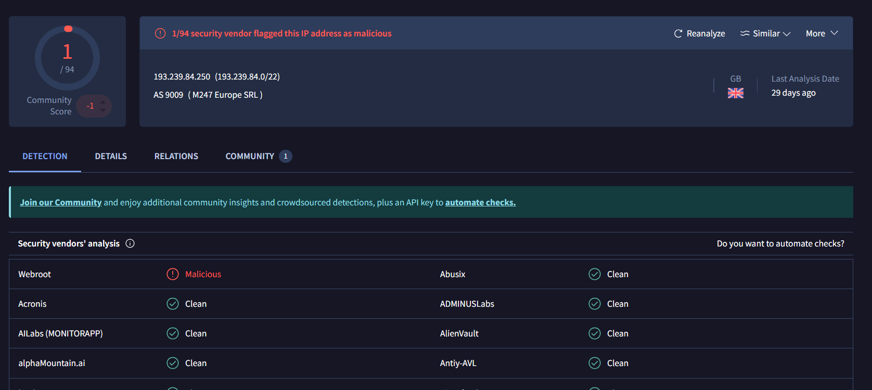

<https://www.virustotal.com/gui/ip-address/40.67.252.175>

<https://www.virustotal.com/gui/ip-address/84.255.95.10>

<https://www.virustotal.com/gui/ip-address/104.124.102.29/detection>

<https://www.virustotal.com/gui/ip-address/52.167.249.196/detection>

<https://www.virustotal.com/gui/ip-address/52.109.8.20/detection>

<https://www.virustotal.com/gui/ip-address/13.107.42.23/community>

<https://www.virustotal.com/gui/ip-address/20.36.236.157>

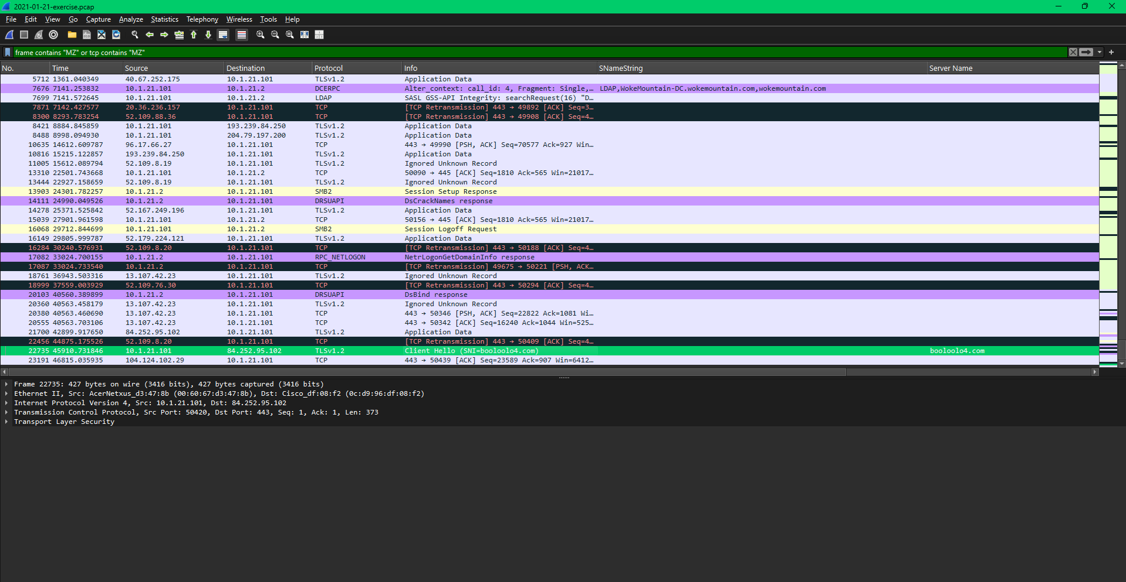

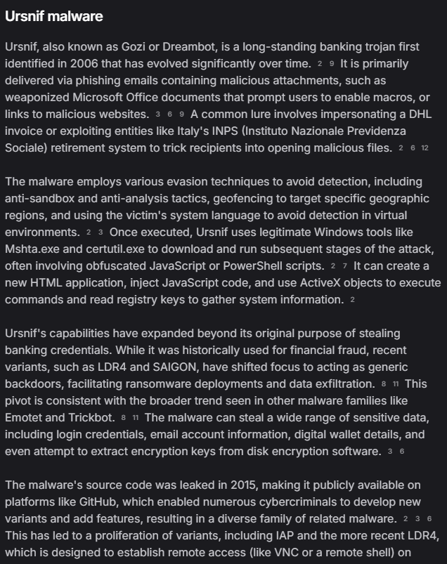

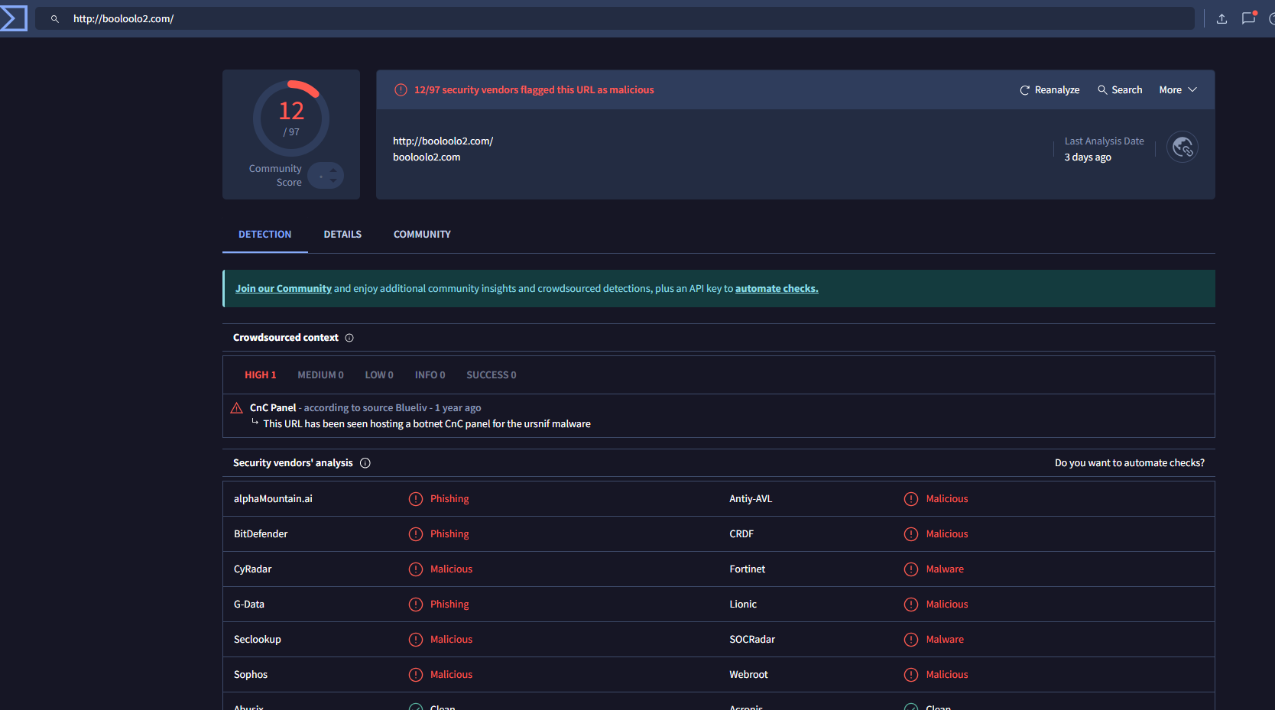

* Most packets are ACKs or TCP segments being reassembled, which means they are fragments of much larger payloads—most likely full Windows executable files. Multiple retransmissions and out-of-order packets appear. This is often seen in large file transfers (especially over the internet) and can be normal during malware or software downloads.
* Several external sources are sending data to the same internal host on a variety of ports (HTTP, HTTPS, others).
* There is consistent communication from 185.186.244.130 to 10.1.21.101 over TCP port 80, the default HTTP port, matching a typical file download scenario.
* There was also evidence of payloads coming from domains known to be associated with malware (such as greatewallfirewall[.]xyz).

### **Event 12: ET JA3 Hash - [Abuse.ch] Possible Gozi**

* **Source**: 10.1.21.101
* **Destination**: 72.21.81.200

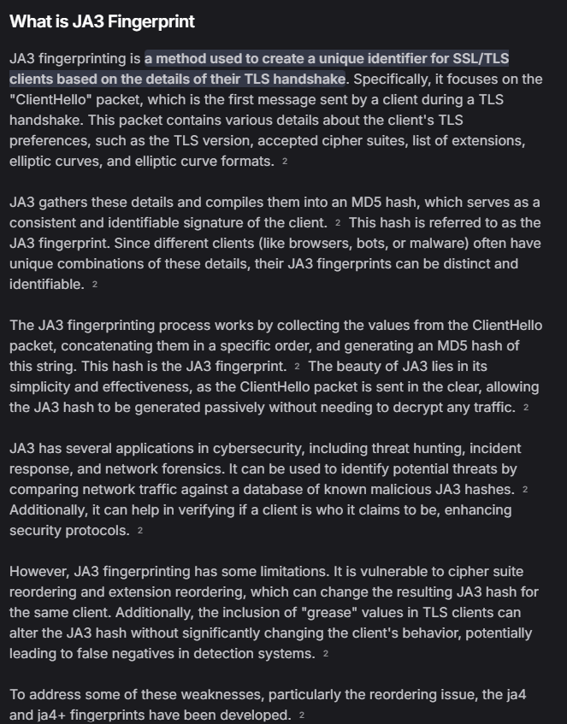

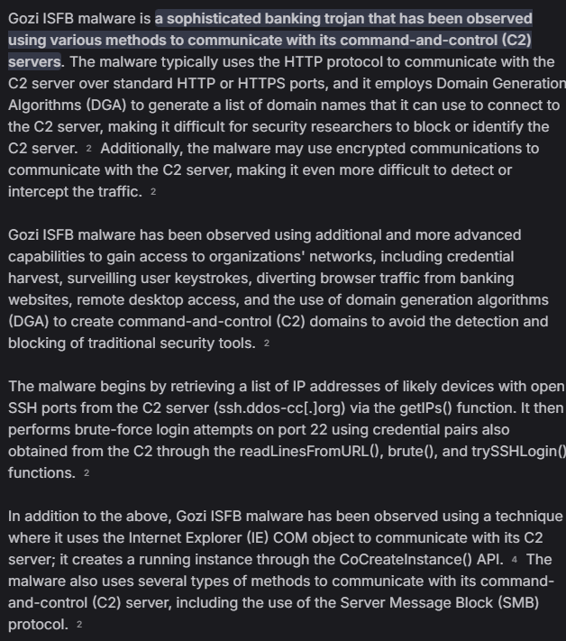

ip.addr == 72.21.81.200 && ssl

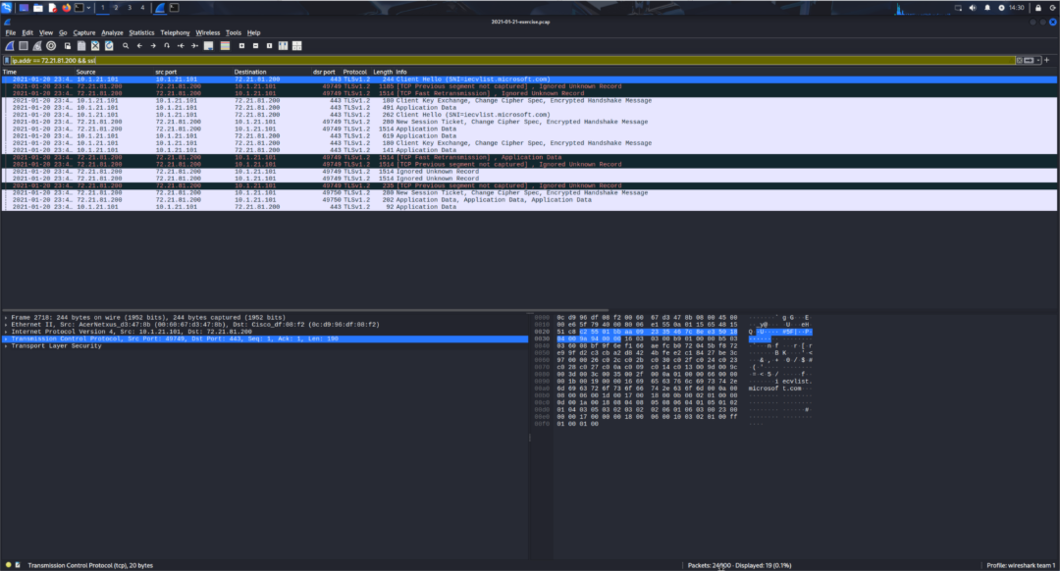

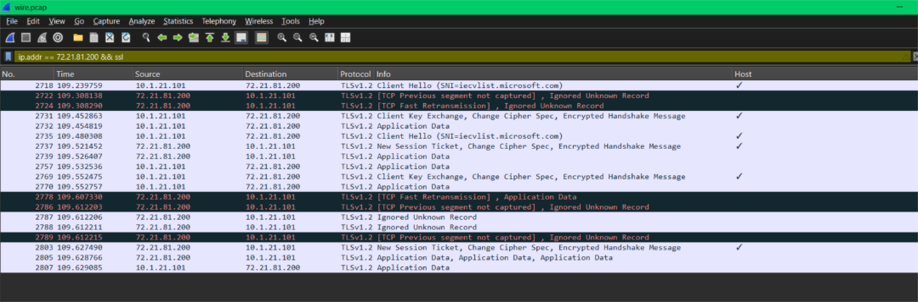

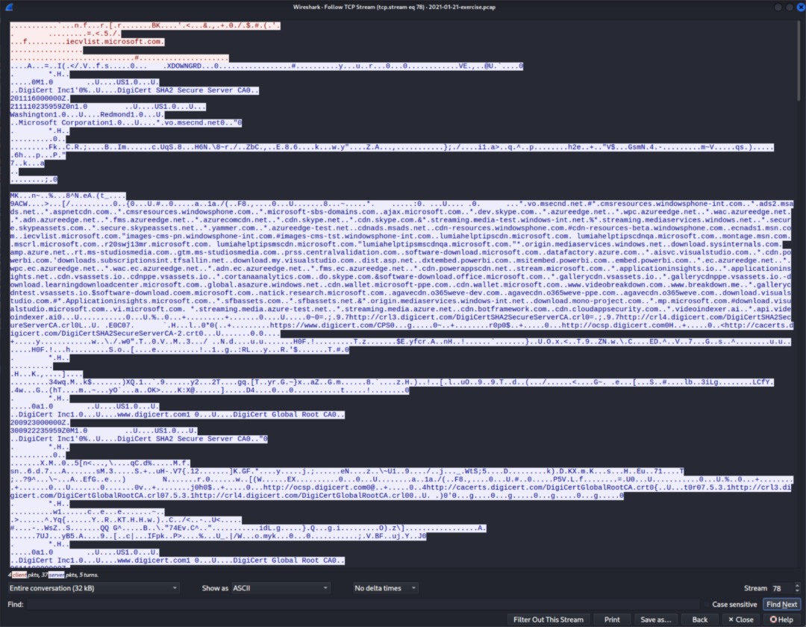

<https://www.virustotal.com/gui/domain/iecvlist.microsoft.com>

<https://www.virustotal.com/gui/ip-address/72.21.81.200>

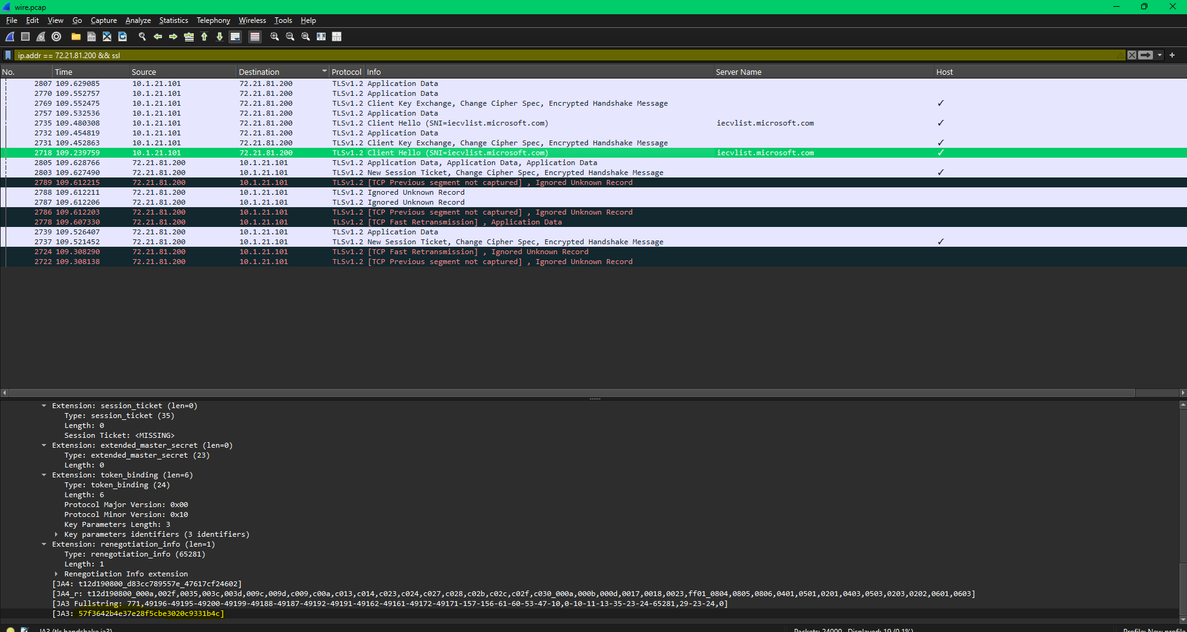

57f3642b4e37e28f5cbe3020c9331b4c – ja3 fingerprint

<https://sslbl.abuse.ch/ja3-fingerprints/>

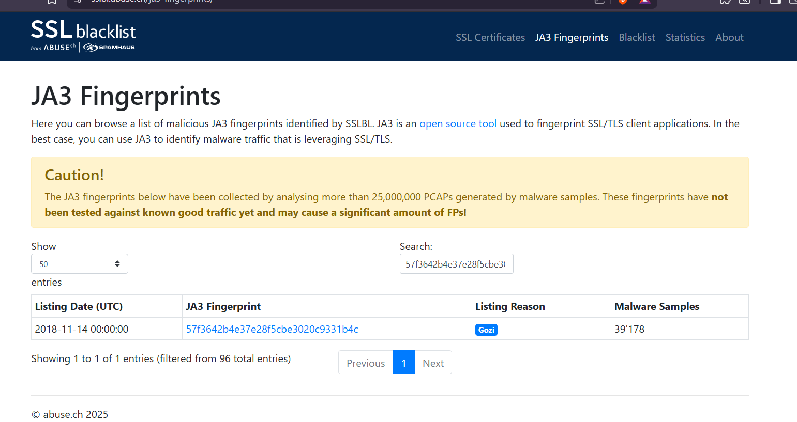

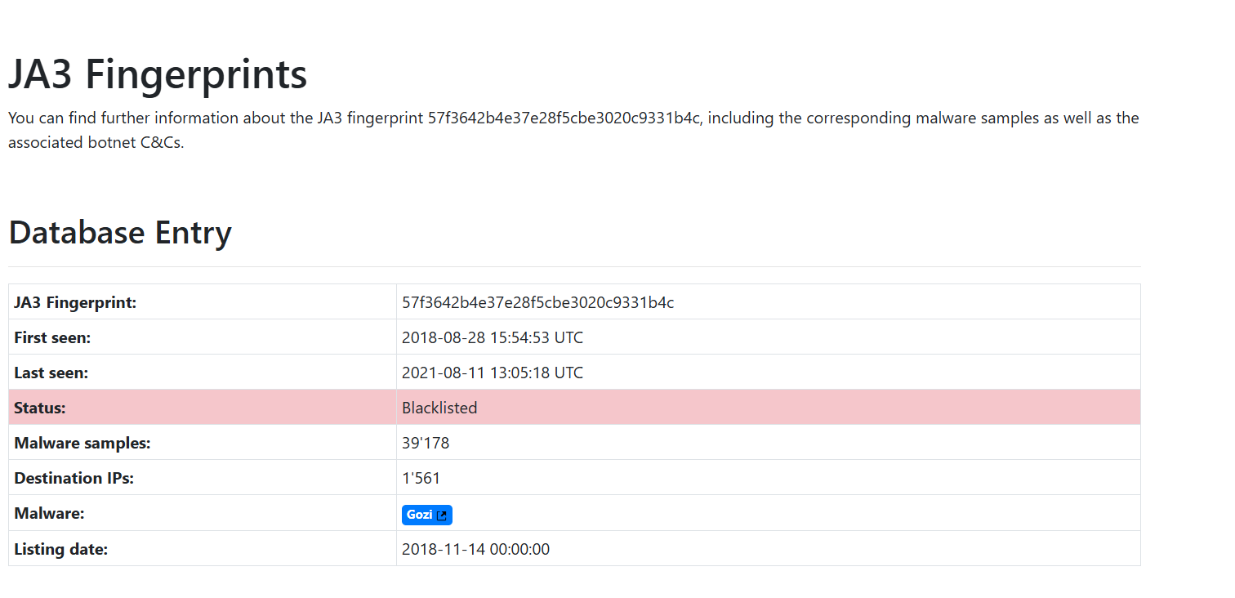

<https://malpedia.caad.fkie.fraunhofer.de/details/win.gozi>

The internal host 10.1.21.101 established an encrypted TLS session with external IP 72.21.81.200, using the SNI iecvlcist.microsoft.com and a JA3 fingerprint that matches the Gozi banking trojan, as identified by Abuse.ch. The packet stream includes DigiCert certificate chains and domains designed to mimic legitimate Microsoft infrastructure—a common evasion tactic for Gozi command-and-control. Multiple encrypted TLSv1.2 packets were exchanged during this session. Checking the JA3 fingerprint associated with iecvlcist.microsoft.com confirms it is linked to Gozi malware. These findings, along with prior detections of executable file fragments from suspicious IPs, confirm ongoing Gozi C2 activity within the network.

### **Event 13: ET POLICY External IP Lookup Domain (myip.opendns.com in DNS lookup)**

* **Source**: 10.1.21.101
* **Destination**: 208.67.222.222 (OpenDNS)

<https://www.virustotal.com/gui/ip-address/208.67.222.222/detection>

dns.qry.name contains "myip.opendns.com"

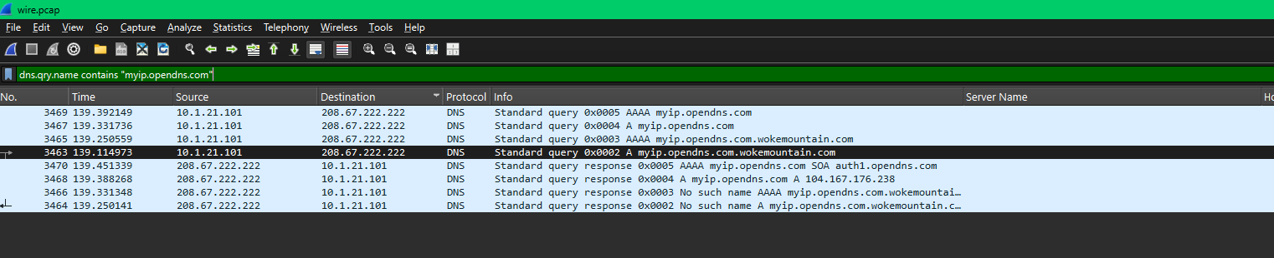

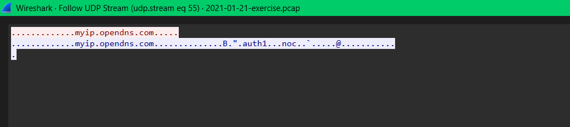

<https://www.virustotal.com/gui/ip-address/104.167.176.238>

* myip.opendns.com is a special DNS trick used to discover the public IP address of the device making the query.
* However, malware also uses this trick to learn its own public IP address after infecting a system (so it can report its location to a command and control server).

### **Event 14: ET INFO Dotted Quad Host RAR Request**

* **Source**: 10.1.21.101
* **Destination**: 162.0.224.165

http.request.uri contains ".rar"

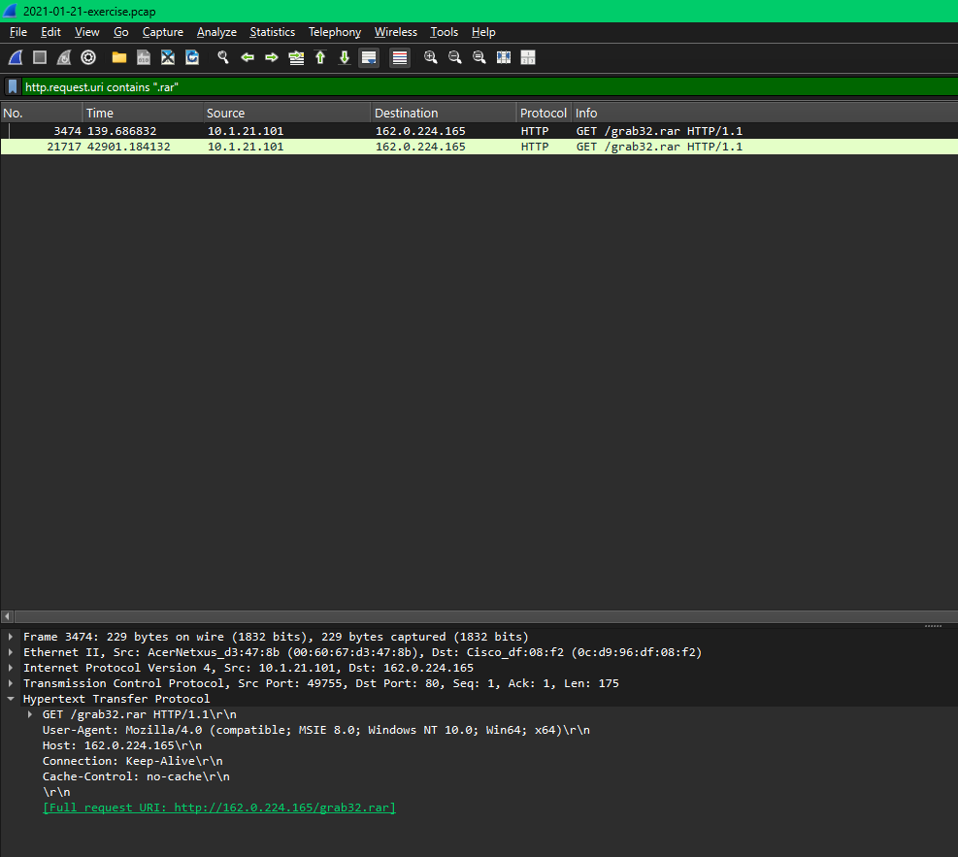

162.0.224.165

<https://www.virustotal.com/gui/ip-address/162.0.224.165>

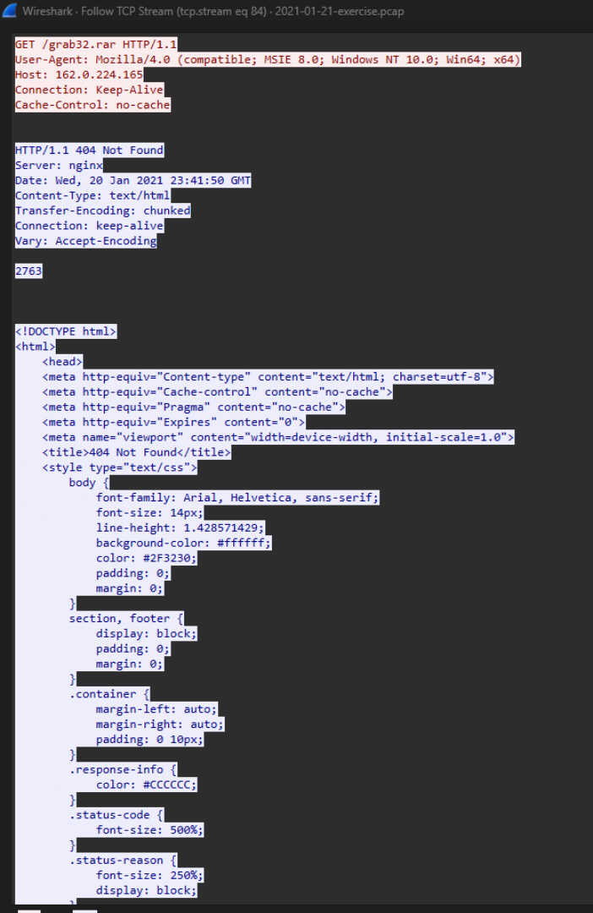

**<https://www.virustotal.com/gui/ip-address/162.0.224.165>**

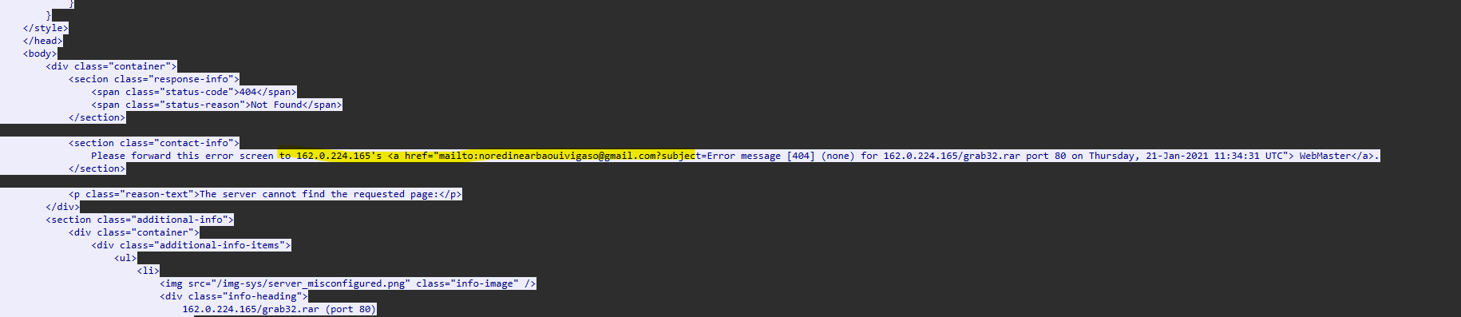

* Internal host attempted to download grab32.rar from 162.0.224.165 (raw IP).
* HTTP response: 404 Not Found but request itself is suspicious.
* .rar archives are commonly used for:
  + Packing multiple malware components
  + Hiding exfiltrated data
  + Bypassing AV with password protection
* User-Agent mimicked Internet Explorer (common in scripts).
* This is likely a **second-stage malware payload** or data collection kit.

### **Event 15 & 16: ETPRO MALWARE Zeus Panda Banker / Ursnif Malicious SSL Certificate Detected**

* **Source**: 193.239.84.250 and 184.252.95.102
* **Destination**: 10.1.21.101

ip.addr == 193.239.84.250 || ip.addr == 184.252.95.102 && ssl

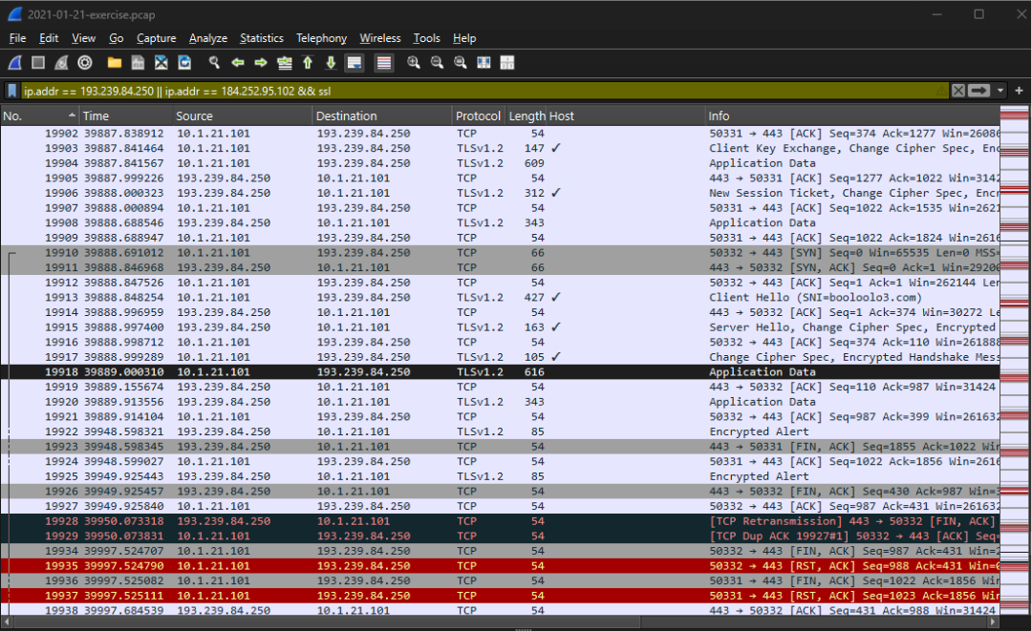

<https://www.virustotal.com/gui/ip-address/193.239.84.250>

<https://www.virustotal.com/gui/ip-address/184.252.95.102>

* TLSv1.2 sessions established with known malicious IPs:
  + 193.239.84.250 (Zeus Panda)
  + 184.252.95.102 (Ursnif)
* Application Data exchanged after handshake — likely encrypted payload or C2 commands.
* Confirms **active malware communication using encrypted channels**.

**IDENTIFYING USER:**

Infected machine IP Address – 10.1.21.101

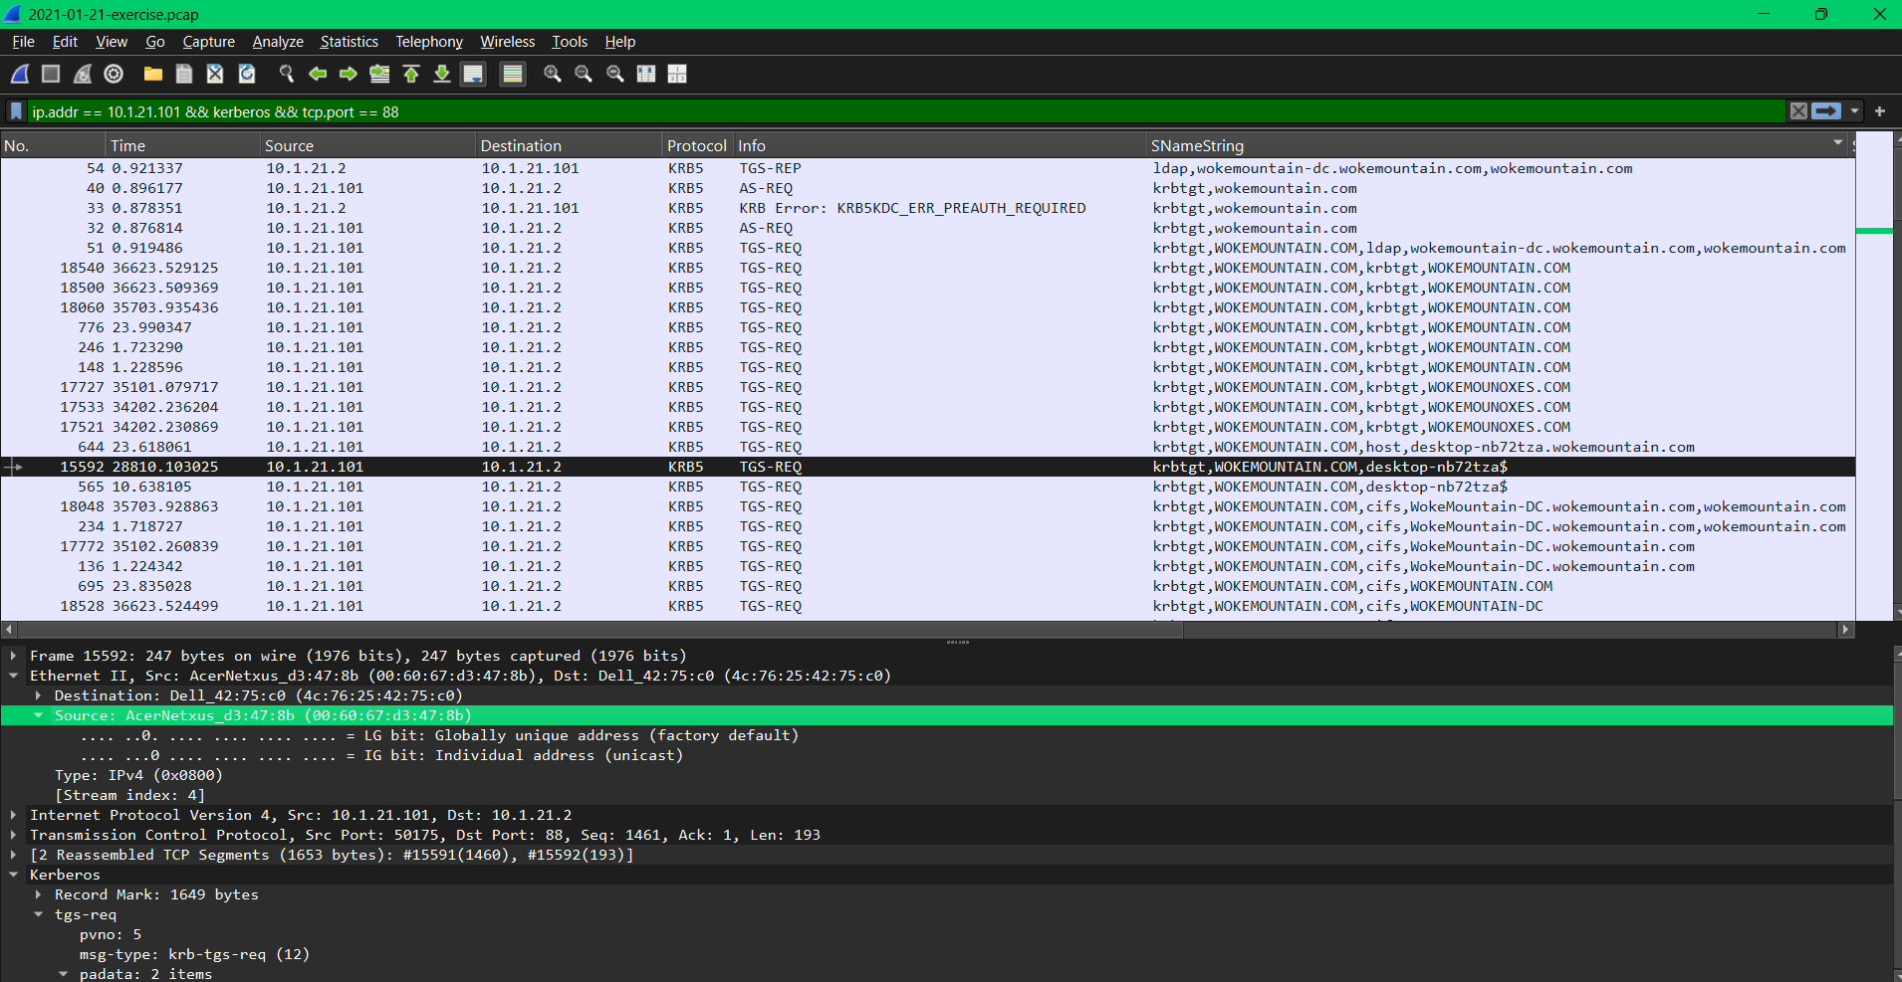

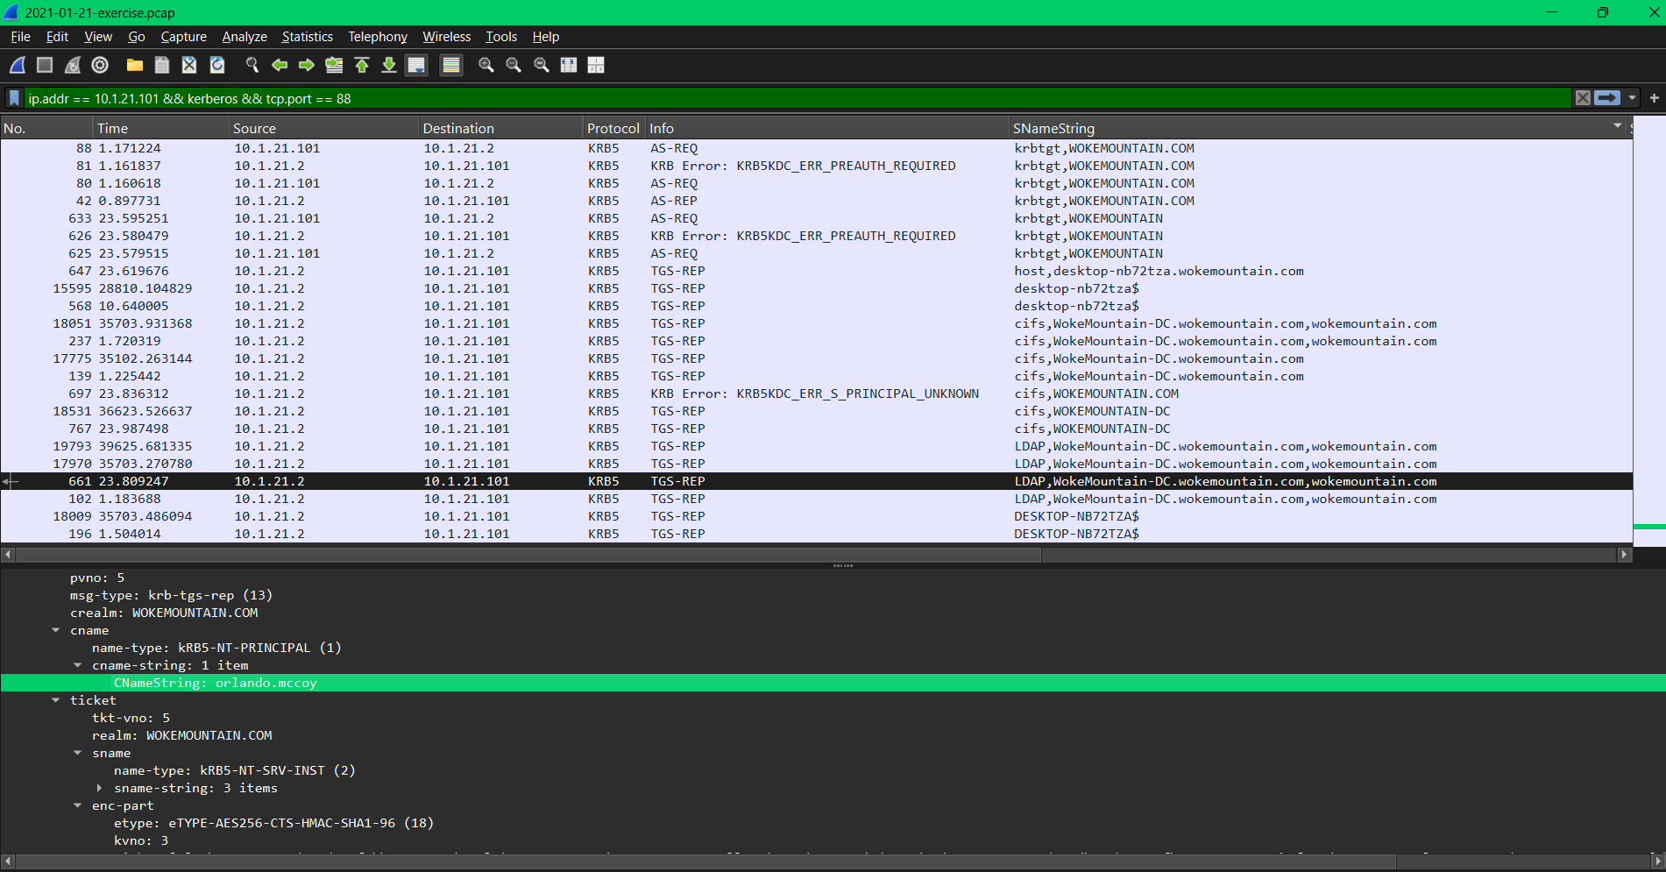

Username: Orlando Mcoy

Hostname: DESKTOP-NB72TZA.wokemountian.com  
Mac: AcerLan_d3:47:8b (00:60:67:d3:47:8b) - Acer Workstation

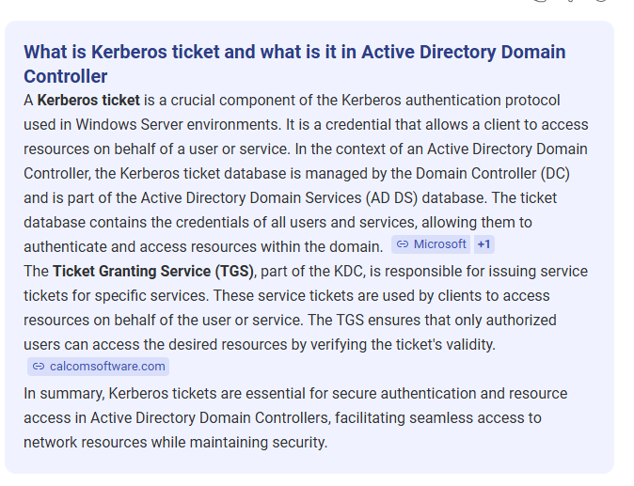

During the initial review of network traffic involving the domain controller (10.1.21.2), an unusual pattern was observed: a non-domain controller host (10.1.21.101) was initiating communication with the domain controller over RPC-related ports. This prompted further investigation into Microsoft Remote Procedure Call (MS-RPC) traffic, specifically protocols like DRSUAPI, DCERPC, EPM, and general RPC_NET activity. These protocols are critical in Windows environments, especially in Active Directory, where they are used for replication, remote management, service discovery, and credential-related operations.

Because domain controllers rely on RPC-based services for replication and administrative communication, any unauthorized or abnormal RPC session directed at a domain controller can indicate malicious behavior. Attackers often abuse these services—such as using DRSUAPI to perform a DCSync attack—to extract password hashes or replicate directory data. 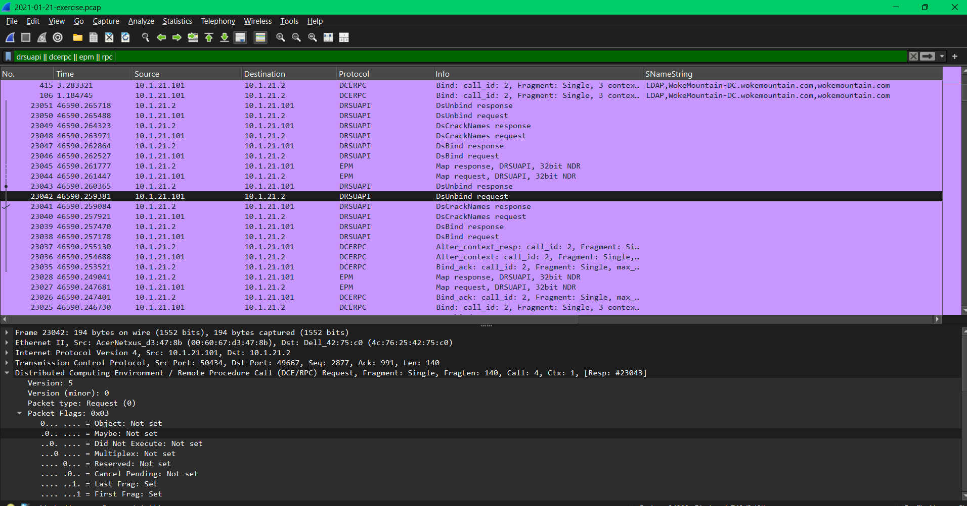

DRSUAPI is the Directory Replication Service Remote Protocol used in Active Directory environments for replication between domain controllers. It operates over DCERPC and allows domain controllers to request and receive directory updates using operations such as GetNCChanges.

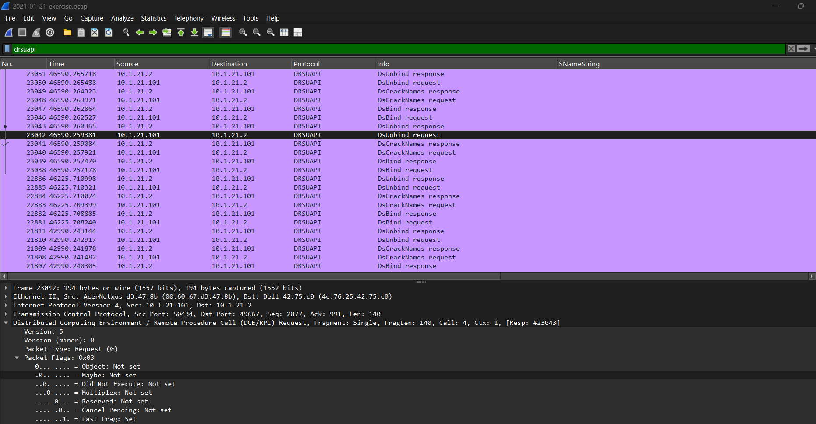

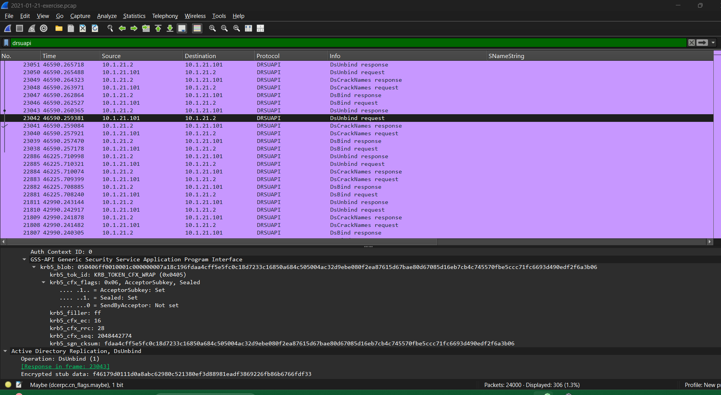

In the analyzed packet capture, filtered using drsuapi in Wireshark, the host **10.1.21.101**, which is **not a domain controller**, initiates a replication session with the domain controller at **10.1.21.2**.

The communication uses Kerberos authentication, and encrypted data is present, This activity is unauthorized, as only domain controllers should perform DRSUAPI operations. The behavior matches the DCSync attack pattern described in **MITRE ATT&CK technique T1003.006**, The short session, use of replication interfaces, and the role of the initiating host confirm this as credential theft through abuse of Active Directory replication.

* File Hashes

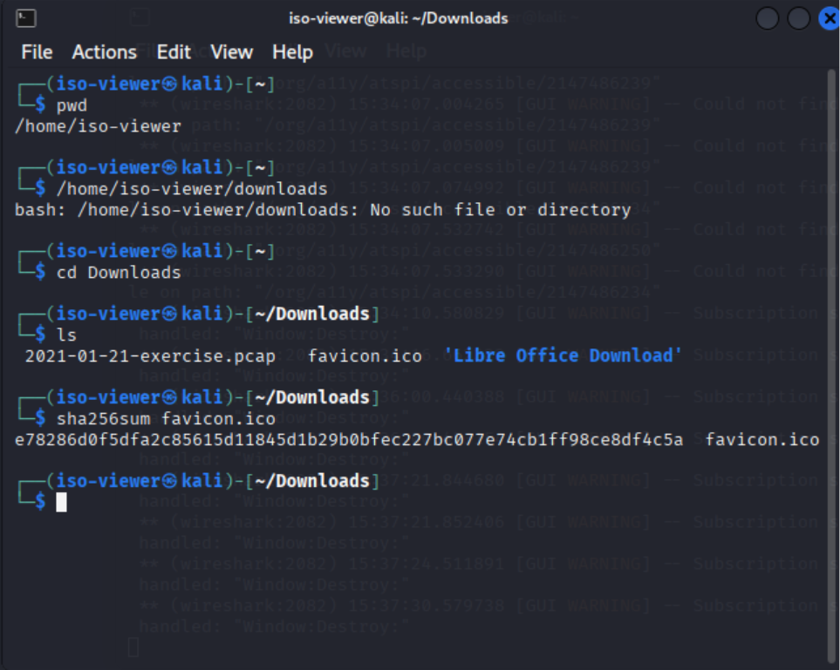

E78286d0f5dfa2c85615d11845d1b29b0bfec227bc077e74cb1ff98ce8df4c5a – hash for favicon.ico

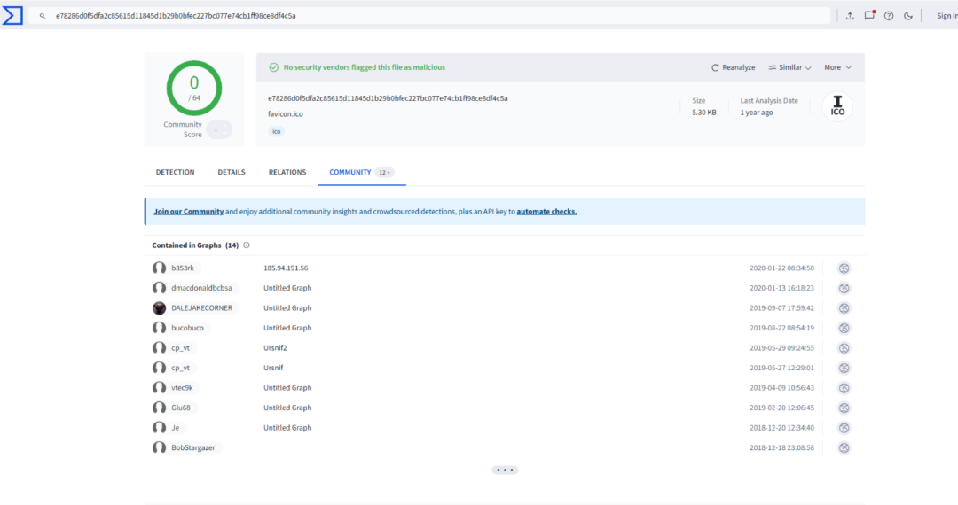

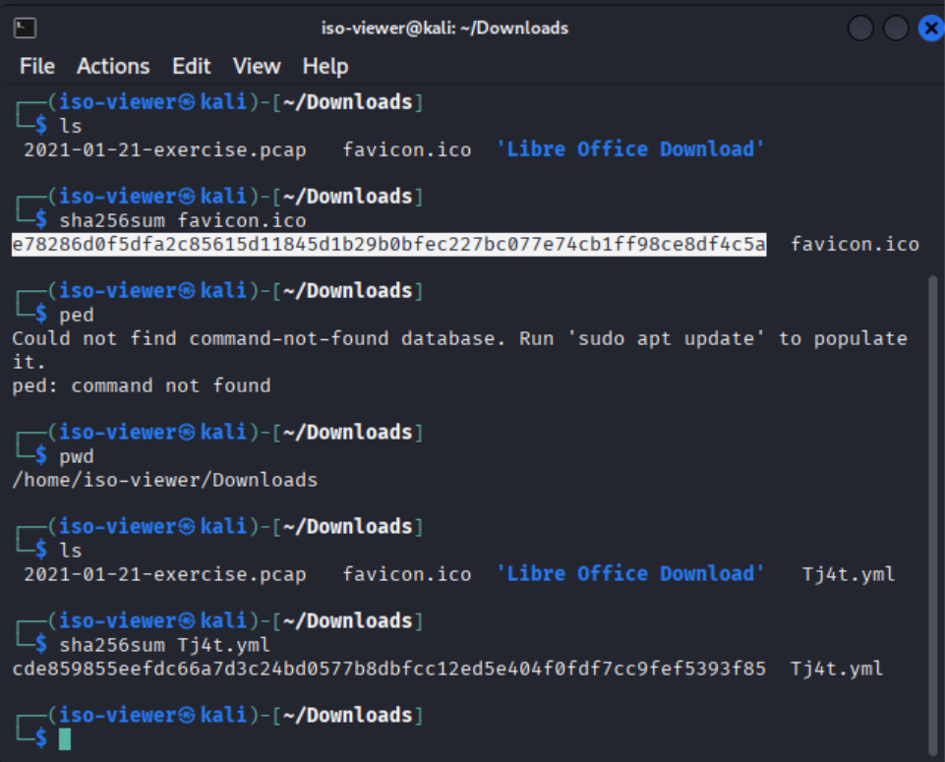

Cde859855eefdc66a7d3c24bd0577b8dbfcc12ed5e404f0fdf7cc9fef5393f85 – hash for Tj4t.yml

